Demographic forecast of population dynamics in the regions of the North-West Russia in 2000-2005

Based on the established trends of birth rate, death rate and migration, the Strategic Developments Center “North-West” issued a demographic forecast for subjects of the North-western federal area until year 2025 (http://www.csr-nw.ru/content/data/article/file/st44_1021.pdf).
The following forecast algorithm was used for this purpose. Changes in the population of the territory meant the result of interaction of two processes: natural population dynamics (birth rate/ death rate) and mechanical population movement connected with entry and exit of population from this territory. In order to make adequate demographic forecasts for regions and municipal entities (ME), information was collected about the age structure of male and female population of each federation subject of the NWFA, and of each ME. Considering these data and based on the elaborated algorithm, two forecasts were proposed for each ME: a forecast considering migration, and a forecast considering only natural dynamics of ME population. In total, about 500 demographic forecasts were made for regions and municipal entities of the North-West.

Pessimistic variant
The pessimistic variant of demographic forecast in the North-West implies persistence of conditions of death rate and birth rate on the level of year 2000, and migration – on the level of the late 1990s. In this forecast the year 1990 is regarded as the zero, basic level. Under such conditions, compared to year 1990, population decrease equal to 10% will be observed even in Kaliningrad region. In Petersburg this figure will be equal to 30%, compared to year 1990.

Middle variant
The middle variant of demographic forecast in the North-West means that levels of birth rate and death rate in the near 10-15 years will reach values which they used to have in the favorable mid-1980s, but intensity and direction of migration flows will not change. This could be suggested in a situation when economic well-being of the population allows to recover previous birth rate and death rate figures, but the governmental migration policy does not change. However, calculations show that such birth rate increase and death rate decrease could not even in 25 years change the trend of population decrease that will be equal to 13 % on average in the NWFA.

Optimistic variant
The optimistic variant of demographic forecast in the North-West implies growth of population of Leningrad agglomeration (including Saint Petersburg, Leningrad, Novgorod and Pskov regions), caused by an inflow of about 2 million migrants over 25 years. The majority of migrants – 1.58 million people – are expected to come from outside the area. Stabilization of the North-West population is possible on the level of 14 million people, which is only 3% lower than the figure of year 2000.
The resulting figures of assessment of the demographic situation forecasts are provided in the table (table 1). They show that in the NWFA, in 2005, if the pessimistic variant of situation development takes place, the population of the area will reduce by more than 25% compared to year 2000, and will amount to 10.7 million people.
If the middle variant takes place implying growth of the birth rate and decrease of death rate while keeping migration rates at the year 2000 level, population of NWFA is, nevertheless, is destined to reduction to as few as 12.6 million people. 270 thousand migrants, which is a small figure for the time period equal to 25 years, who, according to this forecast, will come to the NWFA, are not capable of compensating for the reduction of population.
Dynamic development of Leningrad agglomeration (great number of ports, transport and commodity flows), as well as Karelia and Kaliningrad, are laying the basis now for migration of workforce to these area and, consequently, to increase of population. To keep the population of the NWFA at the level of 14 million people by year 2025, the number of migrants should amount to 1.5-2 million people, which is, experts say, is quite feasible.

Table 1

Absolute figures of assessment of the demographic situation in the NWFA in 2025 (pessimistic, middle variants and the variant of Leningrad agglomeration growth), thousand people

 | Initial state | Pessimistic variant | Middle variant | Migration | Optimistic variant | Migration
 | 2000 | 2025 | 2025 | 2025 | 2025 | 2025
Republic of Komi | 1123,9 | 746,3 | 897,2 | - 169,3 | 897,2 | - 169,3
Murmansk region | 970,6 | 566,2 | 651,9 | - 237,8 | 651,9 | - 237,8
Vologda region | 1316,1 | 1053,9 | 1188,6 | - 37,5 | 1188,6 | - 37,5
Arkhangelsk region | 1489,2 | 986,3 | 1166,8 | - 125,0 | 1166,8 | - 125,0
Republic of Karelia | 761,8 | 588,9 | 700,3 | 81,6 | 700,3 | 81,6
Kaliningrad region | 946,8 | 814,1 | 956,3 | 113,8 | 956,3 | 113,8
Saint Petersburg | 4660,6 | 3476,7 | 4087,8 | 266,1 | 4756,4 | 905,7
Novgorod region | 720,9 | 521,8 | 619,7 | 30,7 | 803,4 | 208,6
Pskov region | 790,6 | 561,7 | 660,8 | 24,0 | 756,4 | 117,2
Leningrad region | 1666,6 | 1401,3 | 1682,1 | 323,5 | 2096,17 | 723,6

Demographic forecast in municipal entities of the North-West

Demographic forecast of population in municipal entities (MEs) allows us to see underground processes occurring in the system of settlement inside the subjects of the North-West federation. This forecast is based on detailed information about the sex-age structure of population of NWFA municipal entities, age coefficients of death and birth rates, and migration inflow over the last 3-5 years. For each municipal entity a forecast was made, in the result of which its demographic potential was calculated. Forecast results are provided in the map materials.
In a paper on municipal entities, three basic indicators were determined:
1. Demographic potential (DP) – is a relative change in the population of a ME over 25 years, in per cent, as compared to the year 2000. The assessment employed the pessimistic forecast implying that birth and death rates and annual migration balance remain on the level of year 2000 during the period in study.
2. Population natural growth potential (NG) is a relative change in the permanent population of a ME in 2000, provided migration rate is equal to zero;
3. Migration growth (MG) is an average annual (over the last 3-5 years) migration balance, as per 1000 people, that characterizes the migration process in a ME established by the end of the 1990s.
Demographic potential (DP). Analysis of map materials allows us to evaluate the demographic situation in the North-West in general. Depending on the changes in population, the territory of a municipal entity is painted on the map (Fig. 1) with a certain color: the lighter the color is, the greater the population decrease is in a ME.

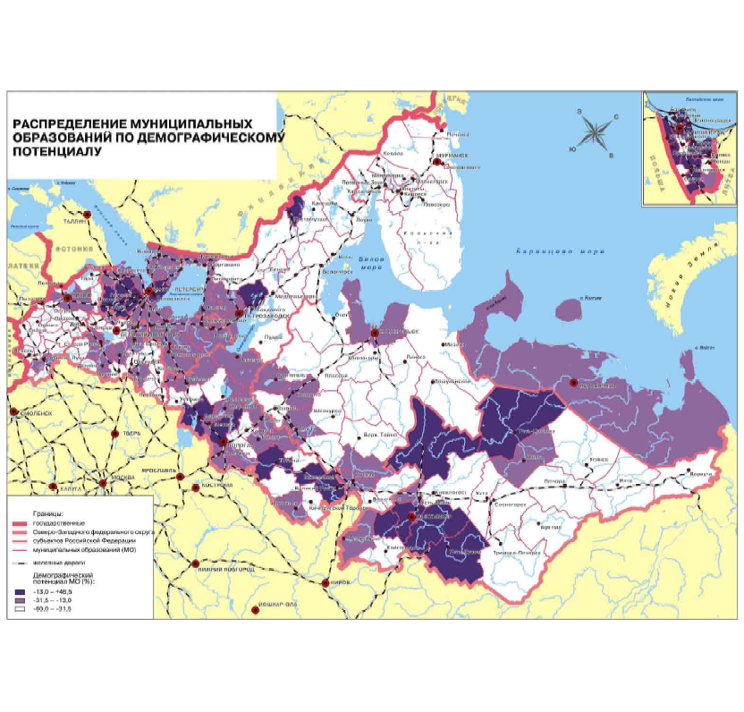
Legend: Distribution of municipal entities by demographic potential

The established picture has its structure and peculiarities. Firstly, the white north clearly outstands, formed by Murmansk, Arkhangelsk regions, Republic of Komi and the northern part of Karelia, the region with a drastic population decrease.
The position of the Republic of Komi, whose territory is painted unevenly, is also of interest. The Russian population of this region passed the stage of demographic transition (transition from the high birth rate to the low one), while national minorities of these territories keep the traditional stereotype of reproduction (high birth rate). That is why in territories where the local population of the North lives, the demographic situation is more stable, while in territories where the Russian population lives, a serious reduction in the population is being observed.
The next clear element of the structure of settlement system is a darker strap starting in the west of Leningrad region and extending up to the eastern end of Vologda region. In fact, it is the most economically active zone of Russia`s North-west.
The demographic potential of the NWFA southern territories – Novgorod and Pskov regions - is much worse than in the central part of the North-West, which is in general typical of this part of Russia.
Natural growth (NG). The NG map (Fig.2) reflects the process of natural growth/loss of population without considering migration, that is the demographic potential of the population residing in the territory now. The map shows that the situation with the natural growth in the north of the NWFA is comparatively favorable (due to Russian migrants who came to these regions in the epoch of industrial exploration of the north in the 1940-1980s, and local peoples with a traditionally high potential of natural growth). By this factor, Leningrad, Pskov and Novgorod regions are in the hardest situation.

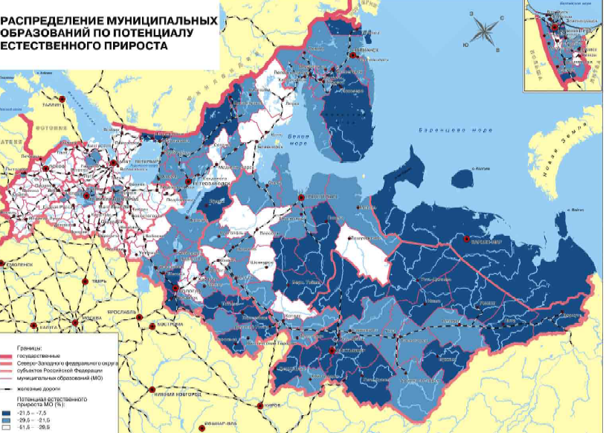

Distribution of municipal entities, by natural growth potential
Migration growth (MG). The picture of migration flows is practically the reverse of the natural growth picture. As a rule, people leave the north for the south. However, there are territories in the north where there is a migration inflow, and there are territories in the south left by people. Migration attractiveness of Novgorod and Pskov regions is not very high. In terms of migration attractiveness, Kaliningrad and Leningrad region, especially territories around Saint Petersburg, are outstanding in the NWFA south (Fig. 3).

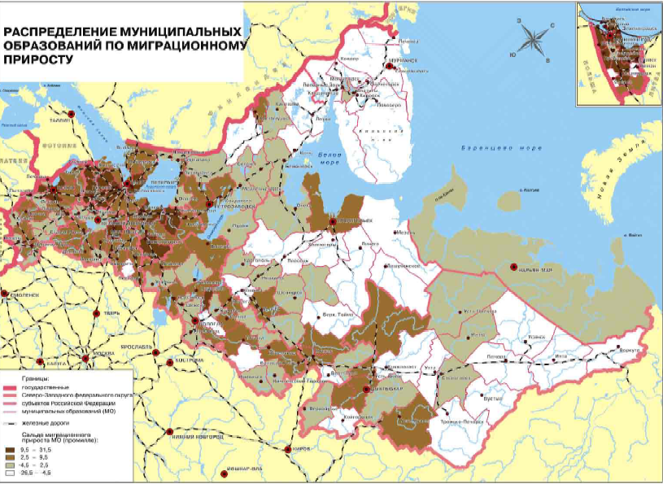
Legend: Distribution of municipal entities by migration growth

