


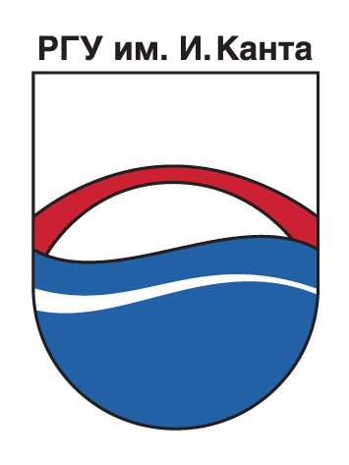


PROJECT
WORKING GROUP 1

The statement and perspectives
of the Urban-rural relations / partnerships in the NW Russia especially in Kaliningrad region

Report prepared by experts Natalia Klimenko and Andrey Levchenkov

Kaliningrad
September 2008
Experts:
Natalia Klimenko, Doctor of Geography, Head of the Methodology and Information Department of the Division for Research, associate professor of the Department of socio-economic geography and geopolitics at I. Kant State University of Russia
Andrey Levchenkov, Doctor of Geography, associate professor of the Department of socio-economic geography and geopolitics at I. Kant State University of Russia

Content of the report

1. Overview of Urban-rural relations/partnerships in NW Russia
1.1. Terms of reference in Russia
1.2. Internet-overview of the term “urban-rural relationships and partnership” in Russia
1.3. Distinction of handling between the terms “urban-rural partnership” and “urban-rural relationship”
2. The statement of urban-rural relationship/partnership in Kaliningrad region
2.1. The territory of Kaliningrad agglomeration
2.2. Socio-economic patterns of urban-rural relationships
2.3. Inter-municipal cooperation
2.4. Spatial structure of the local self-government
2.5. Cross-border cooperation
2.6. Resume
3. Recommendations for urban-rural development in Kaliningrad region
3.1. Completion of the reform of local self-government
3.2. Development of territorial planning and inter-municipal cooperation as a basis of URP
3.3. Transition form decision of political issues to the social-economical issues in the inter-municipal cooperation
3.4. Introduction of URP ideology to Regional strategy of agro-industrial sector development.
3.5. Diversification of rural areas functions in the context of urban-rural partnership development
3.6. Urban-rural networking development in the field of sub-urbanization regulation.
3.7. Delegation of greater powers on management of development of recreation areas from the federal, regional level to the municipal one
3.8. Development of the URP cross-boundary cooperation with neighboring countries
3.9. Development of inter-municipal cultural exchange
3.10. Enhancement of public service accessibility for the population
Annexes

1. Overview of Urban-rural relations / partnerships in NW Russia

1.1. Terms of reference in Russia
Despite the fact that this way or another Russian science (primarily economic geography, municipal engineering, urbanistics, etc.) paid sufficient attention to urban-rural relations there were no serious work carried out in a field of urban-rural partnership. First of all it can be explained by the fact that urban-rural relations were considered only in the context of the perspective development of big cities, for which rural area was taken as “territorial expansion” basis.
Thus, the context of urban-rural relations in regions of Russia contributes to agglomerations development connected to the exhaustion of city resources for realization of its functions including the placement of manufacture and the necessity for its development within a wider territorial basis. From the urban position the surrounding rural area is taken as a territorial resource for development of housing and industrial construction as well as the recreational zones for the cities dwellers.
Such neighborhood places rural area surrounding the big cities among the most dynamically developing territories of the region. However the most successful development of rural territories usually takes place in the spheres directly not related to introduction of agricultural production. Here one may observe high rates in increase of population, that in a reality can be taken as rural only nominally. Due to expansion typical intensive apartment building along the borders of the city turns suburban settlements to "bedrooms" for pendulum migrants working in city. The largest and most profitable enterprises are not of agricultural structure and do not belong to the property of rural municipalities, consequently they do not bring the essential profit in the local budgets.
The ideology of agricultural determinism by which the countryside development is mainly relates to realization of agricultural functions dominates in the Russian studies of the countryside. According to the Federal Law «About common principles of local self-management organization in Russian Federation» agriculture is not covered by the sphere of responsibilities of local self-management, at the same time this field plays a major determine role for municipal economy. This fact defines the necessity of turn from very specific aspects of the countryside to wider handling of rural areas development.
Today urban agglomerations are also one of the main features of modern productive forces accommodation and settlement of the Russian regions expressed in the development of the large cities and occurrence around of them of quickly developing congestions of the occupied places. There is no doubt that these are the most active " centers of growth " of any region, major important areas of concentration of: the administrative, scientific and design organizations, unique establishments of culture and art, most qualified staff, progressive and innovative fields.
The urban agglomeration territory represents a uniform territorial complex (uniform social and economic complex), though its management and even planning are connected to the certain difficulties of administrative character (belonging to various municipalities, etc.).
From the point of planning and management rural-urban relations represent the complex enough phenomenon abounding with now-a-day and potential conflicts in spheres of nature management and land use.
The development of rural-urban partnership within the framework of urban agglomerations is capable not only to create conditions for the mutual account of development interests of both the city and its suburban zone, but also to give certain synergetic effect both on local, and on regional (and, probably, interregional) levels.
Taking into account the above we can identify two basic models of the rural-urban relations considering the conditions of development of NW Russia (pic. 1).
First one is typical for the territories of large urban agglomerations. The feature of this model is active spatial expansion of the city being the agglomeration core, intensive investment activity, high conflict rate regarding the nature management and land use. The specific character of urban-rural relations is based on a principle of differentiation, i.e. hyperconcentration restriction of economic and demographic resources at the city - centre, on the one hand, and stimulation of suburban minor specialized centers development according to these functional differentiation. It is achieved by redistribution of agglomeration center development resources on territory of a suburban area. Development of Kaliningrad agglomeration is the most striking instance of this model.

Model 1 | Model 2

Picture 1. Urban-rural relationship models

The second one is typical for small and medium-sized cities zones of influence in peripheral areas. The feature of this model on the contrary is the necessity for strengthening of organizational role of the city-center in relation to its surrounding territory. The specific character of urban-rural relations is based on a principle of cooperation, i.e. infrastructure development and mutual interrelations intensification between the organizing center and secondary (sub-regional) centers of a territory. This model is typical for such cities of Kaliningrad region as Chernijakhovsk or Sovetsk.
With reference to socio-economic conditions of the Northwest regions of Russia it is possible to identify the following perspective rural-urban partnership directions (further - URP):
- Creation of favorable conditions for recreation.
- Utility-economic cooperation.
- Microclimate improvement of urbanized territories.
- Housing construction development.
- Organization of inter-settlement system of public service centers.
- Development of agricultural production market.
- Development of transport infrastructure and inter-settlement transport services.
SWOT-analysis of these directions and conditions for their realization in relation to urban and rural areas as well as synergetic effect of their development were conducted (tab.1).
Integrally, the analysis of the Table 1 allows making a conclusion that the development of URP gives a number of advantages concerning perfection of regional development conditions, namely:
- increase of a general efficiency and reduction of territorial development capital intensity at the expense of realization of the complex approach to development of the functionally interconnected territories;
- increase of standards and quality of living at the expense of development of social infrastructure and increase of social services accessibility, development of the labor market;
- ecological conditions improvement of territories at the expense of formation of ecological network with strengthening of urbanized territories compensatory development mechanisms;
- investment climate improvement of the territories at the expense of their common infrastructural arrangement, creation of conditions to increase the entrepreneurship activity, development of information base of entrepreneurial sphere development.
The above-stated advantages of URP create the following opportunities for spatial development:
- Development of spatial base for realization of economic functions;
- Increase of economic and demographic potential of the territories;
- Increase of ecological capacity of the territories;
- growth of investment activity and profitability of the budgets on different levels.
Basic shortcomings of URP development are reduced to growth of expenses on development and maintenance of transport, engineering and social infrastructures, and also expenses for realization of nature protection measures. Development of the market of local agricultural production and, as a consequence, increase of food safety of the region is braked by low investment and entrepreneurship activity in agrarian sector. In addition the spatial development of various economic functions occurs, as a rule, at the expense of reduction of the agricultural land area.
Inefficiency of spatial development strategy, as well as the realizations of its separate measures, create threats of aggravation of general transport service efficiency problems, deterioration of economic functions realization conditions of the territory, pollution increase, deterioration of quality and comfort of living environment, loss of valuable agricultural lands.
Table 1
Directions and conditions of urban-rural partnership
Directions of URP | SWOT-analysis of URP conditions |  |  |  | Synergetic effect  (the purpose of URP)
Directions of URP | Urban area |  | Rural area |  | Synergetic effect  (the purpose of URP)
Creation of favorable conditions for recreation - organization of places for short-term and long-term recreation in a suburban zone | Advantages:  Organization of places for short-term and long-term recreation of the urban population | Disadvantages:  Increase of transport peak loads during the weekends and tourist season | Advantages:  Organization of places for short-term and long-term recreation of the suburban population | Disadvantages:  Urbanization and growth of anthropogenous loading on natural and agrarian territories | Increase in territorial recreational capacity, quality of life, health improvement of population, increase in regional recreational appeal at the international and Russian services market, growth of profitability and competitiveness of tourist sector of the region.
 | Possibilities:  Sectoral and territorial diversification of recreational complex | Threats:  Worsening of problems concerning transport provision and general transport service effectiveness | Possibilities:  Development of recreational functions of the coutryside | Threats:  Degradation of recreational potential of the territories
Utility-economic cooperation –the acceptance by suburban zone of city landmark factors with complex organization of infrastructure and utilities system. | Advantages:  Decrease in industrial hyperconcentration, its sanitation and development pressure consequences at the urban area | Disadvantages:  The necessity of the additional investments in utility infrastructure development of spatially isolated economic objects | Possibilities:  Appearance of additional labour vacancies, additional income in the local budget | Threats:  Increase in development pressure of a territory, pollution growth, growth of expenses on measures aimed at indemnification of consequences of industrialization | Decrease of cumulative expenses on engineering arrangement of territories at the expense of integrated approach to its organization and development, improvement of common social climate and standard of living of the population, increase of investment attractiveness of territories and land price
 | Possibilities:  Territorial base expansion for realization of economic functions | Threats:  Decrease or lack of advantages for industrial concentration | Possibilities:  Improvement of common infrastructural arrangement of territories and increase of their investment attractiveness and commercial value | Threats:  Degradation of agricultural, ecological, recreational and other functions of rural area
Improvement of microclimate of urbanized territories - formation of system of a ecological network strengthening the compensatory development mechanisms of urbanized territories | Advantages:  Improvement of ecological situation, reduction of urban area pollution | Disadvantages:  Increase of expenses on nature protection measures | Advantages:  Preservation of ecological potential of rural areas | Disadvantages:  Increase of expenses on green belt surrounding the cities considering its basic limiting functions | Common improvement of ecological conditions, increase of ecological capacity of territories, improvement of population health, reduction of morbidity level, increase of the population quality
 | Possibilities:  Increase of the population quality of life , increase of comfort ability of living environment conditions | Threats:  Presence of ecological restrictions of production capacities perspective growth | Possibilities:  Development of agricultural, ecological and recreational functions | Threats:  Presence of ecological restrictions of economic use of territories
(Table 1 continued)
Housing construction development – acceptance of city population part by the suburban area. | Advantages :  Partial solution of overpopulation problem as well as provision of population with housing | Disadvantages:  Growth of peak loadings on transport system in connection to pendulum migration of a labour force, traffic increase | Advantages :  Growth of investment activity in the sphere of perspective housing construction development | Disadvantages:  Agricultural land area decrease | Increase of life quality level at the expense of population housing conditions improvement, increase of urban demographic potential without increase of population density
 | Possibilities:  Urban demographic potential growth | Threats :  Inefficiency of transport system operation during the peak loadings, air pollution increase by transport emissions | Possibilities:  Housing construction development, improvement of provision the population with housing | Threats :  Loss of valuable agricultural lands, degradation of agricultural potential of a territory
Organization of inter-settlement public service system | Advantages :  Partial unloading of urban public service organizations at the expense of creation of their branches and one-profile establishments in suburban zone area | Disadvantages:  Increase of expenses on development and maintenance of branches of the enterprises involved in service infrastructure sphere in suburban area | Advantages :  Development of rural social infrastructure | Disadvantages:  Increase of expenses on development and maintenance of public services infrastructure | Increase of life quality level at the expense of morbidity level decrease, increase the social boons and household services availability
Organization of inter-settlement public service system | Possibilities:  Increase of overall performance of the public service organizations | Threats :  Inefficiency of public service organizations performance | Possibilities:  Improvement of conditions of population provision by the public services | Threats :  Worsening of public services availability conditions
Agricultural production market development | Advantages :  Improvement of agricultural production supply conditions | Disadvantages:  Low competitiveness of local agricultural production | Advantages :  Increase of demand of local agricultural production and improvement of their realization conditions | Disadvantages:  Low competitiveness of local agricultural production, low investment activity in agricultural sector | Increase of food safety, development of agricultural production market infrastructure, including local production, diversification of agrarian sector specialization, improvement of investment climate in agrarian sector
Agricultural production market development | Possibilities:  Decrease of agricultural production cost | Threats :  Dependence on external agricultural production supply | Possibilities:  Development of agrarian sector, growth of agricultural enterprises profitability | Threats :  Degradation of agricultural sector
Development of transport infrastructure and inter-settlement transport service | Advantages :  Improvement of objects and settlements accessibility in the suburban area | Disadvantages :  Increase of expenses on transport infrastructure development and maintenance | Advantages :  Development of transport infrastructure in the countryside | Disadvantages :  Increase of expenses on transport infrastructure development and maintenance, reduction of the agricultural lands area | Increase of population living standards and quality of life at the expense of availability increase of the public service organizations and population mobility.
 | Possibilities:  Population mobility increase | Threats :  Worsening of pendulum migration problems | Possibilities:  Increase of cost and investment attractiveness of the land along the main highways | Threats :  Loss or degradation of valuable agricultural lands

1.2. Internet-overview of the term “urban-rural relationships and partnership” in Russia

Nowadays there are 3 search systems that dominate in the Russian sector of Internet which shared wide sectors of search traffic. They are Yandex, Google and Rambler. The rest– Yahoo!, MSN, Aport and others occupy a small part of this market and do not influence the main situation.
Google
1. «Urban-rural partnership». Two references are given:
– www.dip.pu.ru/download/bolotov637.doc is connected with an educational program for the year 2005. Spatial Dimensions of European Union Policies of the Department of European Researches at the Faculty of International Relations of Saint-Petersburg State University. It is connected with ESDP – European Spatial Development Perspective (Towards Balanced and Sustainable Development of the Territory of the European Union).
– www.vasilievaa.narod.ru/mu/csipfo/kpr/frames/guide/esdp.htm ESDP itself.
2. «Urban-rural cooperation». 11 references are given which deal mainly with sociological notions such as migration of population. There is also a reference to the Program «Neigbourhood in the Baltic Sea Region INTERREG III B, 2000-2006».
3. «Urban-rural relationships». More than 90 references are given but only 2/3 of them are to the point. To the mentioned EU policy and migration www.prometeus.nsc.ru/archives/exhibits/migrat2.ssi the following is added:
– urban-rural and agroindustrial cooperation in the field of trade, food market,
– demography (urban-rural distinctions),
– policy (mixed districts).
4. «Inter-municipal cooperation». 5550 references are given. The main one is the site of the Russian National Congress of Municipalities and other variations on the same topic: reports, regional organizations and others.
Yandex
It searches much worse and gives less convenient search results. It seems that a lot of similar notions the system casts aside or does not show.
1. «Urban-rural partnership». 10 references are given but only 2 of them are to the point.
The first one is the same www.sir.edu/download/bolotov637.doc. The second one is connected to the European Spatial Development Perspective (Towards Balanced and Sustainable Development of the Territory of the European Union). Three more deal with migration, one – with urban-rural contrasts and one more – with exchange and continuum.
2. «Urban-rural cooperation». 26 references are given. As a rule different notions which deal with the collocation «urban-rural» occur. Here one can find both migration and infrastructure...
3. «Urban-rural relationships». 40 references are given, 22 of them are connected with urban-rural travel, urban-rural migration and exchange. It practically resembles the search for urban-rural cooperation.
Above all 429 references are given among them urban-rural migration predominate.
Rambler
1. «Urban-rural partnership». It resembles in fact all other search systems results although it gives 115 references. The same are reference to ESDP and a lot of sites which do not refer to URP at all or simply to relationships between rural and urban areas.
2. «Urban-rural cooperation». 275 sites are given or 826 documents. The result is the same anyway. A lot of rubbish!
3. «Urban-rural relationships». 929 sites with 2960 documents are given. After filtering urban-rural relationships proper mainly connected with sociology and urbanistics dominate. It is worth mentioning the existence of the notion in the “Economic model of local governance”, which deals with urban-rural territory system formation. In revealing relations the role of cities for the surrounding rural area is vital. Numerous references to migration processes, creation of both urban-rural communities and urban-rural social infrastructure are connected with sociology.
Thus, from numerous forms of urban-rural cooperation in Russian conditions one can speak less about such a notion as “urban-rural partnership”. If it is “cooperation” the leading role is given to migration flows of labour forces in which rural area is dependant. To greater extent in Russia we can speak about “relations” in cooperation between rural areas and cities. These relations are in such field as demography, migration, political studies, commerce, etc.
The most developed form of contacts between municipalities (both urban and rural) is nowadays inter-municipal cooperation. And this cooperation is being realized in Russian conditions now against a background of a municipal reform. As we will see later these rare examples of Urban-Rural Partnership which occur in Russia are hidden behind the term “inter-municipal cooperation”.
But this fact does not indicate that there is no “urban-rural partnership” in Russia at all. If this notion is not mentioned in literature (internet) it does not mean that partnership does not exist itself.

1.3. Distinction of handling between the terms “urban-rural partnership” and “urban-rural relationship”

An essential point is to define the principle difference between the terms “urban-rural relationship” and “urban-rural partnership”. In other words the point is to draw a distinction where “relationship” becomes “partnership”.
The main fields of cooperation between cities and rural areas are the following:
Industrial
– agriculture products, timber and resources extracted in rural areas delivery for processing to cities (enterprises which deal with processing of agriculture output, timber, raw materials and fuel are situated mainly in cities);
– work made by city construction firms in rural areas;
– material and technical provision of rural areas (fuel, energy, machinery and equipment, spare parts and others supply).
– raw materials and semi-finished products delivery for processing to rural areas (less spread).
Social
– Serving of rural inhabitants by social institutions situated in cities (medical care, educational, cultural and sport institutions).
Consumer
– Serving of rural population by city consumer, commerce and catering enterprises, financial and credit institutions.
Recreational
– rest of town-dwellers in rural areas;
– (more rarely) rest of rural inhabitants in resort and recreational institutions situated in cities;
Labour
– pendular labour migration of rural inhabitants to towns;
– (more rarely) pendular labour migration of town-dwellers to rural areas;
Administrative
– management of rural territories development in the framework of municipalities at the head of which are towns.
Social and political
– activities of political parties and public organizations which have headquarters in towns on the territory of rural areas.
Connection between towns and rural areas are realized by means of transport communication, connection and telecommunication, financial flows. An essential part of links is realized spontaneously without authorities being involved.
Actors of urban-rural relationships are various industrial, social, transport enterprises as well as population, authorities (bodies of local and state governance), political parties, public organizations and natural complexes (natural territorial complex, landscapes).
Urban-rural partnership can be mentioned only in case of existence of organizational and legal infrastructure of the cooperation between the actors of urban-rural relationships (agreements, control structures, work groups, etc).

2. The statement of urban-rural RElationship/ partnership in Kaliningrad region
The Federal law 131-ФЗ “On the main principles of the local self-government organization in the Russian Federation” that was approved in 2004 defines significant potential for URP development in the fields of LSG responsibilities such as:
– town-planning regulation and land use;
– environment protection, usage and protection of water-bodies, wastes management;
– organization of transport service;
– public service – health service, education, house building, consumer service market;
– small business development, support of small growers of agricultural produce, etc.

2.1. The territory of Kaliningrad agglomeration

In spite of compactness of the territory, displacement of population in Kaliningrad region is characterized by inequality and asymmetry towards the geographical centre of the region. Kaliningrad is the one large city in the region with the population of 427,8 thousand people. The rest towns are small and have population up to 50 thousand people.
Kaliningrad agglomeration, which takes a little more than a quarter of the territory of the region, concentrates about 73% of the population (including a half of rural population of the region) and 80% of its economic potential. It is a high-urbanized territory with urban population of more than 86%, and quite inhabited (186 people/km²) according to both Russian and European criteria. Nowadays amid total population reduction of the region the Kaliningrad agglomeration is distinguished by growth of urban and rural population (pic. 2, table 2).
Table 2
The main indicators of development of Kaliningrad agglomeration
Indicators | Kaliningrad agglomeration | Kaliningrad region
Population, thousand people,  Including urban  rural | 688,6 (73%)  593,4 (81%)  95,2 (44%) | 946,8 (100%)  728,3 (100%)  218,5 (100%)
Territory (without water areas of lagoons), thousand km² | 3,7 (28%) | 13,3 (100%)
Density of population, persons/km²  including rural | 186  25,7 | 71  15,9
Urban population share, % | 86,2 | 76,9
Number of urban settlements, items,  Including those with population above 20 thousand people | 12  2 | 25  5
Number of rural settlements, items,  Including those with population above 2 thousand people | 385  9 | 11
Average population of urban settlements, thousand people.  Including data without taking into account Kaliningrad city | 49,5  15,0 | 29,1  12,7
Average population of rural settlements, people. | 294 | 188
Source: own calculation based on the data of the Regional branch of the State Statistic Service in Kaliningrad region.

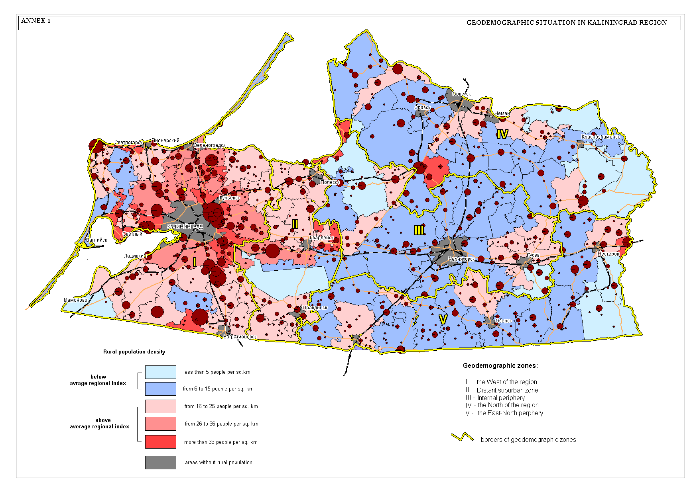
Picture 2. Geo-demographic situation in Kaliningrad region

The peculiarity of territorial development of Kaliningrad agglomeration lies in sectoral development conception. Sectored development conception is expansion of a city along merging to it radial directions. The dominating direction is axis of the broad transport frame of the region Baltiysk-Kaliningrad-Gvardejsk-Chernyakhovsk-Gusev-Nesterov. This route is of federal significance and included in the system of Trans-European transport corridors (1«А» «Riga-Kaliningrad-Gdansk» - the bifurcation «Via-Hanseatika» from «Via-Baltica»). The route Kaliningrad-Mamonovo and the road going from Kaliningrad to the airport Khabrovo are related to this category of transport corridors too. These directions have intensive motor and railway communication. There are important marine trade ports, fish port and river ports and border crossings. Other radial directions have regional importance and connect Kaliningrad with marine resorts of federal significance (Svetlogorsk and Zelenogradsk), the northern and southern parts of the eastern periphery of the region (Kaliningrad-Pravdinsk, Kaliningrad-Polessk), and the territory of Poland (Kaliningrad-Baagrationovsk) (pic. 3).
There are a number of zones in the territorial structure of Kaliningrad agglomeration which are distinguished by peculiarity of socio-economic development and functional orientation and hence, by different context of rural-urban partnership development (annex 3):
- Kaliningrad city (the core of the agglomeration, the administrative centre of the region) including:
1-а – historical core (small-size territory where the most remarkable architectural and historical constructions and administrative, cultural and business centers of the agglomeration are located);
1-b – central multifunctional zone (densely built-up area adjoining to the historical part of the city; it is significantly transformed but to a great extent kept old planning with objects of cultural heritage. This zone is being reconstructed and replanned more and more, and changes its look, gaining the functions of the centre);
1-c – external zone of Kaliningrad city (the territory of concentration of the major part of population that is administratively included in the city line; this territory is overbuilt; the population is growing having tendencies to expansion outside the city lime).
- Suburban zone (sub-urbanized zone, which together with Kaliningrad makes wider formation that could be considered as agglomeration itself), including:
2-а – industrial-and-transport subzone of the northern coast of Kaliningrad Lagoon (Svetly-Baltijsk);
2-b – subzone of suburban residential building (Gurijevsk-Vasilkovo-Nizovie-Severny-Yuzhny-Pribrezhny).
- External zone of agglomeration (zone of expansion of direct and intensive influence of Kaliningrad with relatively low dynamic of daily commutation, zone of development of alternative centers for creation of recreational zones, agricultural bases and etc., and promoting unload of the agglomeration. They include:
3-а – recreational subzone (Yantarny-Svetlogorsk-Pionersky-Zelenogradsk-Lesnoy-Rybachiy-Morskoe);
3-b – coastal military-industrial subzone (Baltijsk-Donskoye);
3-c – agrarian territories of Kaliningrad peninsula (Melnikovo-Kovrovo-Romanovo);
3-d – industrial-and-transport subzone of international airport Khabrovo;
3-e – transit subzone of international transport corridors (Ladushkin-Mamonovo, Bagrationovsk).
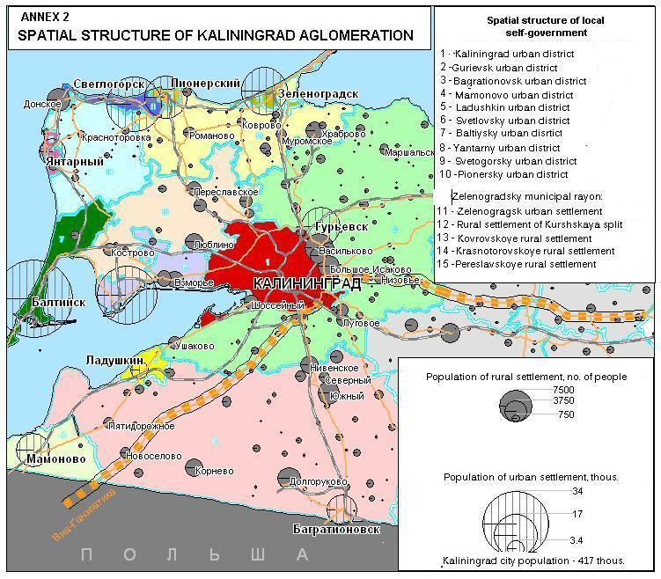
Picture 3. Spatial structure of Kaliningrad agglomeration
Alongside with the authors’ attitude concerning delimitation of the territory of Kaliningrad agglomeration, the opinion of German colleagues (E.E.Korkisch, H.Heinz, 1996) shapes the zone of agglomerative influence of Kaliningrad mostly distributed to the south, i.e. to the zone of trans-European corridors. We are of the opinion that this attitude is based on infrastructural approach is not bare of objectiveness. However, it does not pay too much attention to social gravitation of coastal area of the north to Kaliningrad. From another side, there is an overestimation of influence of the trans-European transport corridors (which are of mostly transit character) on development of interactions between Kaliningrad and its suburbs. Not going into detailed argumentation (which is out of the topic of this paper), Kaliningrad agglomeration will be examined in an extended (and, we believe, more realistic) context.

2.2. Socio-economic patterns of urban-rural relationships

On the grounds of the main socio-economic indexes the district of Bagrationovsk (agricultural production), Svetly region (investments) and Gurevsk urban district (consumer services) can be singled out of the municipalities of the agglomeration (excluding the regional centre). Anyway, even without taking into account Kaliningrad, the agglomeration in whole gives up to 1/3 of the regional index, for example in volumes of regional indexes, for example in terms of volumes of agricultural production (table 3).
Table 3
The main socio-economic indicators of Kaliningrad agglomeration through municipalities, 2007 (% )
 | The amount of able-bodied population | Volume of agricultural production | Investments to the main capital | Retail turnover | Volume of paid consumer services
Kaliningrad | 45,1 | 11,0 | 74,5 | 62,8 | 81,9
Pionersky | 1,2 | 0,2 | 1,6 | 0,8 | 0,4
Baltijsky urban district | 4,1 | 0,2 | 0,3 | 2,5 | 1,4
Svetlogorsky urban district | 2,3 | 0,6 | 0,3 | 1,9 | 2,2
Svetlovsky urban district | 3,0 | 0,9 | 16,9 | 2,1 | 1,4
Bagrationovsky urban district | 4,9 | 14,4 | 0,5 | 3,8 | 0,6
Gurjevsky urban district | 5,4 | 9,9 | 1,4 | 3,5 | 4,4
Zelenogradsky municipal area | 3,5 | 6,5 | 0,2 | 2,2 | 1,7
The agglomeration in whole without Kaliningrad | 24,4 | 32,7 | 21,2 | 16,8 | 12,1

Regarding the volume of paid consumer services (629,3 million of rubles) the Gurevsk urban district can be singled out. On the whole the positive tendency for the development of paid consumer services should be maintained according to the prognosis for the period till year 2010. The widening of assortment and improvement of quality of consumer services is expected. The obligatory services (housing and communal, transport and network services) would maintain the leading positions in volumes of the paid consumer services. The growth of volume of paid services to the population in average to 15-18% is expected for medium-term perspective.
There are 29% of business entities of the region outside Kaliningrad. There are more than half of the entities (about 52%) in the zone of Kaliningrad agglomeration (table 4).

Table 4
The division of the business entities within the framework of municipalities (units)
 | Quantity on  1.01.2008 | 1.01.2007
 | Quantity on  1.01.2008 | Quantity | in % to the total outcome
Total | 48770 | 45984 | 106,1
Municipal areas
Zelenogradsky | 812 | 770 | 105,5
Urban districts
Kaliningrad | 34634 | 32302 | 107,2
Bagrationovsky | 1347 | 1356 | 99,3
Baltijsky | 528 | 502 | 105,2
Gurevsky | 3167 | 2711 | 116,8
Laduskin | 89 | 87 | 102,3
Mamonovo | 192 | 199 | 96,5
Pionersky | 298 | 307 | 97,1
Svetlogorsky | 736 | 722 | 101,9
Svetlovsky | 824 | 786 | 104,8
Yantarny | 130 | 127 | 102,4
The region without Kaliningrad | 14136 | 13682 | 103,3
The agglomeration, % | 51,7 | 55,3
The business entities registered in Common State Register of the enterprises and organizations (CSREO) of the Kaliningrad region (without individual businessmen).

As the table 4 shows, the quantity of business entities arises in recreational zone and agricultural regions of the agglomeration. Regarding the patterns of ownership of enterprises and organizations – the private organizations prevail (up to 80%), municipal, state and social organizations also take significant part (up to 10%).

Estimating the quantity and the branch structure of the registered into CSREO business entities we should take into account the eager activity of the Kaliningrad’s enterprises in the agglomeration. The biggest part of business entities works in the sphere of trading and catering as in the whole Kaliningrad region (it’s part is smaller than Kaliningrad but higher than in other parts of the region). The considerable quantity of small building organizations working in the field of housing construction and can be singled out (their specific weight is even higher than in regional centre). Some amount of transport organization can be also singled out.
A lot of companies of the agglomeration succeeded in regional level, widening the sphere of their activity outside their districts. These are “Vesava” Ltd (building, Vasilkovo village), “Avangardstroy” (building, Svetlogorsk). For some other enterprises the agglomeration zone became the area for the placement: “Estate” Ltd (production of refrigerators) “Konkordia” Ltd (meat semi-finished products) “HIPP” (baby food), “DSV-transport” (logistic centre) and others.
In structure of economy (on the basis of the cost of manufactured production) the agriculture, trading, catering and building prevail in municipalities of the agglomeration (with some variations in some particular municipalities).
Small amount of industrial production can be explained by very small amount of industrial enterprises in agricultural districts. There are machine-building enterprises in other districts (Svetlovsky ship-repair, №82 in Baltijsk), fish canneries (Mamonovo, Vzmorje). In 1990-s the existing industrial enterprises in agricultural districts stopped functioning. At the same time during the last 5-8 years new processing enterprises were founded, for example in such spheres as electronics and electrical engineering, carpet industry, woodworking, extraction and bottling of mineral water, meat-processing and construction materials.
The agriculture is represented by suburban type of economy – intensive production (milk, meat specialization, manufacture of vegetables and potato, eggs) (table 5).
Table 5
The amount of Kaliningrad agglomeration in some indicators of the development of agriculture of the Kaliningrad region, %

Indicators | Indicators  (total), 2007 | Share, %
Indicators | Indicators  (total), 2007 | 1991 | 2007
Gross yield of potato, thousands of tonnes | 30,7 | 34,6 | 30,3
Gross yield of vegetables, thousands of tonnes | 35,5 | 77,7 | 41,7
Gross yield of grain, thousands of tonnes | 23,3 | 29,9 | 15,0
Production of milk, thousands of tonnes | 23,6 | 26,1 | 15,8
Production of eggs, mln. pieces | 159,5 | 90,0 | 84,3
Livestock, thousands of heads | 10,8 | 25,8 | 16,1
Pig livestock, thousands of heads | 11,6 | 34,2 | 27,8
Sheep and goat livestock, thousands of heads | 15,0 | 28,5 | 32,3
Production of cattle and birds and for slaughter (real weight), thousands of tonnes | 18,9 | 38,3 | 49,3

The agricultural productions are represented by big and small farms both. The amount of private (personal) farming is also substantial for processing of agricultural production.
The basis of agricultural sector is represented by collective enterprises. Among the enterprises there are the leading ones, well-known in the region (“Kolkhoz Prigorodny”, Close corporation “Strazh Baltiki”, “Kolkhoz Rossija” and others). A lot of successors of former kolkhozes are practically standstill. There are some large farms, but these are rather exceptions on the on the background of inactivity of the majority of small farmers. Besides the agricultural enterprises there are also fishing kolkhozes in the agglomeration: “Truzhennik morya” (village Rybachy), “Za Rodinu” (Vzmorje). There are three enterprises, which are successfully dealing with animal breeding: Agricultural Company “Prozorovskaya” (Kostrovo), close corporation “Zverohozajstovo Gurjevskoe” (Petrovo) and “Agrofirma Mamonovskaya”. Besides that, the considerable areas are covered with dachas (Kolosovka and especially Sokolniky) with the specific recreational land tenure.
Regarding its specialization, the agglomeration is a leader in oblast’ on parameters of efficiency of milk production, crop capacity, and yield of potato and vegetables. The crop capacity on potato in the agglomeration is highest in the region. Zelenogradsky municipal area takes the second place in the region – 164,6 c/h (122,0 c/h – is an average for the oblast’), Bagrationovsky urban district takes the third place – 151,7 c/h Zelenogradsky municipal area takes the second place in the region – 164,6 c/h (122,0 c/h – is an average for the oblast’), Bagrationovsky urban district takes the third place – 151,7 c/h Zelenogradsky municipal area takes the second place in the region. Regarding the crop capacity of vegetables Zelenogradsky municipal area is an undisputable leader – 283,2 c/h. Out of 67,1 thousands heads of livestock (for 01.01.2007) only 16,1% comes for the agglomeration. The districts of the agglomeration produce about 16% of the regional milk processing on gross production, but they have the indexes of average milk yielding for one cow higher than average indexes of the region. Thus, Zelenogradsky municipal area is the second in the region after Polessky urban district with 3896 kilos. As whole, however, we should state more deep decrease of production in agglomeration and in the region as a whole in 1990s.
It is more difficult to estimate social position in the agglomeration on the basis of statistic data than in the whole region. The development of small business, which is difficult to evaluate statistically due to big specific weight of informal (shady) business also makes the adequate evaluation of the situation more difficult.
The level of official unemployment in zone of agglomeration influence of Kaliningrad is smaller than in the region (without taking into account Kaliningrad). It reflects high employment in informal sector and in Kaliningrad.
The level of job payment is strongly differentiated on the basis of different branches of economy. The job payment in agriculture is more than twice lower than in industry and building. The level of payment in agglomeration is not high; it’s lower than average level in the whole Kaliningrad region, which can be explained by its branch-wise structure – with small specific weight of the branches with high level of job payment. This factor, as well as insufficient quantity of working places in countryside causes high pendulum mobility of the population, first of all between the suburb (to wide extent of the word) and the regional center.
The budgets of municipalities are not high. The transfers of superior budgets make up almost half of the profit of the budget. Besides that, there is a part of population that lives in suburban zone, but works in Kaliningrad; there it pays the income tax. The municipalities have utterly weak sources of replenishment of revenue (because of lack of substantial financial intermediaries on the territory). The taxes, which are collected in municipalities and coming into the budget make up only several percent of the profits of the total budget of the oblast’. The subventions and transfers from the regional budget are not significant. The main part of recourses of the budget is devoted to financing of education and housing and communal services. The solution of the problems of social development of the district, of its pipelines and networks and other task is strongly hampered because of weakness of the budget of district.
The migratory increase of the population is characteristic for the coastal zone as well as for the whole Kaliningrad region. It was especially significant in the middle of 1990-s, then there was the mass departure of Russian population and partially the representatives of other nationalities, including Germans from the countries of the near abroad (especially from Kazakhstan). The dynamics of migration movement of the region remains positive nowadays, but unstable for some particular municipalities. The absolute magnitude of annual increase for the last 4 years are going down and vary within the limits of 3-4 thousands (per 1000 of inhabitants – 3,5-5,5).
The most favorable situation with migration increase is observed in Kaliningrad and its agglomeration. The proximity to the regional centre, the presence of working places, relatively inexpensive real estate – these are the main reasons of inflow of migrants from abroad (table 6).
Table 6
Migration movement in Kaliningrad agglomeration, thousands of people

 | 2003 |  |  | 2006
 | Arrived | Left | Icrease/Decrease | Arrived | Left | Icrease/Decrease
Kaliningrad region | 18566 | 15429 | 3137 | 14361 | 10352 | 4009
Kaliningrad UD | 6262 | 5004 | 1258 | 5333 | 3540 | 1793
Pionersky UD | 303 | 193 | 110 | 213 | 130 | 83
Baltijsky UD | 1031 | 799 | 232 | 729 | 577 | 152
Svetlogorsky UD | 655 | 427 | 228 | 404 | 360 | 44
Svetlovsky UD | 794 | 330 | 464 | 703 | 283 | 420
Bagrationovsky UD | 1166 | 1352 | –186 | 655 | 664 | –9
Gurjevsky UD | 2026 | 1032 | 994 | 1479 | 651 | 828
Zelenogradsky MA | 751 | 661 | 90 | 748 | 359 | 389
All the agglomeration without Kaliningrad % | 36,2 | 31,1 | – | 34,3 | 29,2 | –

Although the migration increase grew substantially in 2006 and made up 1793 of people – 44,8% of total migration increase of the population of the population of the region. The migration in the region has both intraregional and interregional character.
There are 108 transport routes in our region. The coastal routes are considered to be the most profitable. The main players of the market of carriage of passengers of agglomeration (out of 25-30 companies) – are the enterprises of the regional centre.. Transport companies in towns of agglomeration outside the Kaliningrad are represented in recreational towns Svetlogorsk, Zelenogradsk (“Svetlogorskavto”, “Zelenogradskavto” correspondingly), in Svetly, (Svetlovsky linii”), Baltijsk and Gurjevsk (OOO “Gurevsk lines-1”), but the volumes of their trips are insignificant. Besides the middle and big transport companies there are small private entrepreneurs using minibuses.
The transport network is developed well. The transport connection between the regional centre – Kaliningrad and the towns of coastal zone is developed the best way. The connection is realized through the railway and bus transport. The railway transport is developed the best way in coastal direction – to Svetlogorsk (via Pionersky) and Zelenogradsk. Thus, there are up to 8 direct runs by the railway station from Svetlogorsk to Kaliningrad (via Pereslavskoe) in autumn-winter season and up to 4 from Svetlogorsk to Kaliningrad via Zelenogradsk. In summer season the quantity of runs is increased up to 12-14 runs (depending on the day of the weak). Zelenogradsk is connected to Kaliningrad by 10 runs, Pionersky – by 4-5 runs and Svetlogorsk by 4 runs. The bus connection, however, is as significant in summer season. Thus, there are 28 bus runs and 25 minibus runs from Svetlogorsk to Kaliningrad daily.
As Svetlogorsk, Zelenogradsk is connected with Kaliningrad in most stable way. There are 32 main runs daily (8 via Muromskoe and 24 via Petrovo). Besides them there are also minibuses, which also establish the connection between Zelenogradsk and Kaliningrad. There is also a connection between Zelenogradsk and settlements of Kuronian Spit (Morskoe, Rybachy). There is also separate connection with the village Melnikovo, there is local connection with village Sosnovka and Verbnoe. Svetlogorsk (Otradnoe) also belongs to the towns of the coastal zone, there the bus connection from Zelenogradsk is realized. The connection, especially with villages is realized in unstable way. In summer season, especially during week-ends (in Svetlogorsk and Zelenogradsk both) there are some additional runs of buses and minibuses.
Regarding the direction to Pionersk – the quantity of routes is significantly smaller than in Svetlogorsk and Zelenogradsk. The most popular route is Kaliningrad-Pionersky (via Romanovo, Zaostrovje) – with 18 runs. Besides Kaliningrad, there are also routes from Pionersky to Pokrovskoe (4 runs) and Donskoe (6 runs). There also transit railway routes Kaliningrad-Svetlogorsk going via Pionersk. There are 8 direct runs to Kaliningrad and 4-5 more via Zelenogradsk. Their quantity is increased during summer season.
The bus connection prevails within the directions to Baltijsk, Bagrationovsk, Mamonovo and Gurjevsk. There are about 20-30 runs depending on the direction excluding minibuses.
The cultural and historic heritage, the monuments of regional and local significance archeological excavations, represent the recreational potential of the territory of the agglomeration in a row with natural conditions (the coast of the Baltic Sea). The main recreation zones are placed at the coast of the Baltic Sea.
The organized tourism is present mainly in Zelenogradsk and Svetlogorsk urban district. Cranz and Rauschen are famous as the recreation zones since the middle of XIX century.
At present time Svetlogorsk urban district is a leader in the Kaliningrad region by the amount of the hotel rooms (up to 70% of the hotel fund of the region). There is a plan to increase the amount of the hotel rooms up to 9,3 thousands by putting into service 6 new hotel and touristic complexes during 2008. Basically, these are going to be the small hotels because the development of this type of business in town is strongly limited by the problem of absence of free areas of recreational land, especially the big areas. According to different plans of the development of Svetlogorsk up to the year 2020 its hotel fund should not exceed its maximum capabilities, which make up around 20000 of places. The exceeding of this figure will reflect negatively not only the infrastructure of the town, but its recreational and touristic perspective as well. It’s also connected with the fact the thousands of Kaliningrad’s residents are rushing towards Svetlogorsk during the week-ends, which makes additional problems for the inhabitants of Svetlogorsk and tourists. At present time there are 47 objects of touristic-recreational complex in the town. These are 12 sanatoriums, 6 boarding houses, 17 of hotel and guest houses, 4 recreation centers etc.
There are about 23% all the hotels and other places for the tourism in Zelenogradsk (more than 2,4 thousands of places). These are more than 20 hotels and guest houses: “Zelenogradsk” (230 places) sanatorium-preventorium “Chaika” (177 places), the hotels “Sambia”, “Koroleva Luisa”, “Baltijskaya korona”, several boarding houses, children's health camps. There are more than 30 of different holiday centers in Kuronian spit. They can accommodate up to 2000 of people. The largest of them are: holiday camp “Diyny” – 630 of places, the holiday center “Lesnoje” – 500 of places, the boarding houses “Baltijskie peski”.
Besides that there are some recreational institutions in Baltijsky urban district – in the town of Baltijsk, village of Mechnikovo (Neuhaeuser), in the Baltic spit.
Besides the organized tourism, which is mainly designed for the guest of the region, the inhabitants of the regions (first of all – the residents of Kaliningrad) prefer unorganized tourism. During the summer time the people of Kaliningrad occupy the Sea cost. The quantity of tourists having rest at the coast by approximate estimate reaches 100-120 thousands of people. The tourists are coming to some remote areas of the Sea coast by car, and by public transport – to Svetlogorsk and Zelenogradsk.
The summer holiday for the kids is represented by health camps. According to the data for 01.01.2007 there were 97 of health camps (without taking into account schools’ health camps) where more than 15 thousands of children had the rest. The most important health camps are placed at Sea cost (Svetlogorsk, Zelenogradsk).

2.3. Inter-municipal cooperation

The processes of inter-municipal cooperation, which took place in the past, were always connected with the establishment of the institution of local government in different kinds: the Unity of Zemstvos was established in Russia in 1904, the Unity of Russian towns were established in 1914 as a social organization. And to the contrary, during the stages of the strongest centralization of the state power in Soviet period of Russian history (since 1930s) then the traditions of self-government and self-organization were crossed out of the social life, there are no examples of realization of some unifying ideas on the level of towns or some other territorial units. The associations and unities of municipalities, which are acting now in Russia, started to appear together with the foundation and development of the institution of local self-government in its current stage – since the end of 1980s-90s. One of two main purposes of their establishment was the transmission of the experience of municipal government to solve difficult problems of government and development of municipalities.
The first organization, which started to champion the interests of municipalities on the top level of State Power, became the Council on local government in Russian Federation (president’s decree of Russian Federation № 874 from 24.08.1995). The Federal law “On the basic principles of the organization of the local government in Russian Federation” came into force the same year.
In 1998 the Council on local government in Russian Federation came to conclusion about the necessity of creation the Congress of municipal foundations on the basis of the same European foundations. Analyzing the arguments put by the founders of the Congress – it’s easy to see the driving forces of the municipal movement of this time – the solution of political tasks for the defense of local government. The unification on the basis of the common solution of economic problems was not that actual for the period, because it was more important – to uphold and defend immature institution of local self-government from encroachments of the State.
Thus, the examination of the foundation of inter-municipal cooperation enables to make a decision that it is the process in demand appeared mainly because of understanding by the municipalities of the objective necessity for the unification to solve the common problems together.
The distinction of Russia from other countries is political context of various kinds of municipal associations. The Federal law “On main principles of local self government organization in the Russian Federation” clearly provides creation of only one kind of municipal associations – the one to provide for remedy. That’s why this kind of municipal association is the most widespread. Functioning of “economic” or “management” associations is not well developed in Russia yet.
The right of municipal associations for inter-municipal cooperation (to solve the economic tasks) is defined by the article 10 of the European charter for local self-government, which states that “the local governments have the right to cooperate and make some associations with other local governments to solve the tasks of common interest”. It’s worth mentioning that the associations of such a type are widespread in European and other countries. For example, there are 262 of joint municipal councils in Finland, which cooperate in the field of electric and water supply, professional education and defense of the children. Two Danish municipalities Holstebro and Struer organized the partnership for the creation and maintenance of the airport. The capital of the partnership was formed from the inpayments of partners and money taken to the credit. Other 4 municipalities created the partnership for the construction and maintenance of the plant for the utilization of domestic and industrial waste in Herring .
Inter-municipal cooperation is not developed because of several reasons:
- Weakness of Russian institution of local self-government, for which, the political questions of defending their rights and guaranties are mostly topical;
- Lack of traditions for common decision of the questions of municipal economics and housing and communal services by several municipalities;
- Insufficient development of the legal base, concretizing the statements of European charter of local government within its part for procedural regulating of inter-municipal cooperation.
The absence of sufficient legal conditions and the practice of activity of such an associations were the reason for entering of two-level of local self-government, which is foreseen by the modern reform. For instance, new Federal law “On basic principles of organization of local self-government in Russian Federation” presupposes obligatory creation on the level of districts of municipal foundations of type “municipal district” as a higher level of municipal government. The purpose of formation of this level is the same as the purposes of creation of economic association – the solution of the questions of local importance, which can be solved by the municipalities of the settled type only unifying the recourses. Besides that, the municipalities will realize the delegated powers of state power (state powers).
So, while choosing the model of territorial organization of local self-government, the legislator could choose the way of full-fledged development of local self-government in settlements and assistance by giving them the conditions for unification into economic association, leaving them freedom for formation of municipalities not on the level of districts. To our mind, such a construction would be more flexible and effective for big spaces of Russia. This plan was not realized. Unfortunately, the legislator chose the way of unification of territorial foundations of local self-government. In our opinion, this circumstance may influence negatively on widening and development of inter-municipal cooperation in Russia.
Regional associations of municipal foundations are unified by municipalities within the subjects of Russian Federation. There are more than 50 of unions and associations of municipalities functioning in Russia at present time, 44 of them form the Congress of municipal foundations of Russian Federation. The activity of such organizations as Associations of rural settlements of Russian Federation, the Union of the towns of North-West of Russia and the Association of municipalities of the Kaliningrad region are the most important for the development of the Kaliningrad region.
Association of Rural Municipalities of the Russian Federation (ARM) is founded on 21.11.2003 to guard interests of Russian rural areas. The initiators were regional associations of Astrakhanskaya, Orenburgskaya and Chelyabinskaya regions. The constituent agreement of such a municipal association presupposes prior its political character and adjudicates protection of local self-government as its main function. Such an aim of the organization setting up seems quite sound due to two reasons. First of all Russian rural areas tend to be the most unprotected from the point of view of human rights for participation in locals self-governance violation. Secondly, the fundamental municipal associations were set up as a rule by towns and settled up problems of local self-government which are radically different from those of rural areas. Even those associations the members of which can be partly rural districts were not oriented on settling specific problems of rural self-governance.
At the same time «…there are still a lot of problems in rural areas. This fact cannot have been reflected on general attitude to the idea of self-governance. Poverty and inconsistency of main targets and power of local authorities discredit the very idea of local self-government». In our opinion it is reasonable that the Association of rural municipalities fits a still unoccupied niche in the field of inter-municipal cooperation: small municipalities of a settled type received their “own” association which is able to settle a lot of problems of provincial Russia by means of inter-municipal cooperation at the level of rural settlements. Specific models of such cooperation are to elaborate and implement in future. And this is a worthy task for the Association of rural municipalities of RF.
Association of towns of Northwest of Russia was founded in 1990 in Cherepovets by representatives of 12 towns when they "... decided reasonable to unite attempts of towns of the North-western zone of RSFSR in the field of settling the problems arose on the basis of equal and voluntary cooperation in political, socio-economic, environmental and other directions". By the year 2006 25 towns were united by the Association from central (8) and north-western (17) parts of Russia. This fact proves activeness of the Association and benefit derived by towns. Since 2001 there has been a United Association of Municipalities “Association of towns of Centre and Northwest of Russia”.
Its political task - to lobby interests of town self-governance - the Association of towns of Centre and Northwest of Russia realizes quite actively. Its representatives constantly participate in work of political bodies which deal with local self-government, in Commissions under the President of RF and Government of RF. A lot of activities of the Association are carried out together with the State Duma, Departments of the President of RF Administration, Congress of Municipalities, Union of Russian Cities, Council of Europe.
The main form of work of the Association is organization of thematic seminars and conferences. The main aim of these meetings is sharing experience in the field of urban development, study, analysis and comparison of Association members’ achievements, other municipal associations, cities of Russia and other countries in the field of local self-government. A specific feature of the Association’ activities in this direction is that every such an activity is practically a project which is elaborated and realized by the Association board supported by one o the cities which takes responsibilities and often covers organizational costs. The city-organizer as a rule is the most advanced one in the chosen field of municipal management and shares its positive experience.
Against a background of not strong regional associations Association of Municipalities of the Kaliningrad region stays apart. It has great experience of cooperation with international organizations from EU countries. Such opportunities together with strong organizational and intellectual potential of executives resulted in the Association quite active work in many field of municipal management.
Analysis of peculiarities of inter-municipal cooperation development in Russia allows coming to the following conclusions.
Government support of inter-municipal activities has been carried out to some extent but not always consistently. First of all, some legislative and other acts (decrees of the President of the Russian Federation, resolutions of the Government, federal programmes) supporting local self-government and inter-municipal cooperation were adopted. At the same time some federal bodies controlling constitutional guaranties for carrying out local self-government (Council headed by the President of RF, corresponding bodies in the President’s of RF Administration and in the Government of RF) were set up. But on the other hand, the acts being in force remained unrealized and created bodies from time to time were liquidated.
Municipal Associations themselves used even this incomplete set of legal and institutional instruments which were formed for them by the state not to a great extent. Above all they had no possibility to influence the situation. And it is not their fault but the trouble of municipal associations because their position as a rule was not understood by the authorities who are in charge of local self-government and inter-municipal cooperation. There are a lot of reasons for such a situation in Russia. But the main one is that authorities do not still understand benefits and advantages which can be granted to citizens by affectively working system of local self-government. At the same time local self-government as an institute of civil society has not managed for such a short period of its existence in Russia to show itself in full measure.
Based on modern ideas of inter-municipal cooperation conditions for formation of this institute in Russia having been created by now cannot be considered enough and sufficient especially taking into consideration need to cooperate not only to solve political but also economic tasks.
This underlines lack of sufficient system for stable and sustainable development of inter-municipal cooperation. This situation does not allow coming to the conclusion that municipal associations manage to achieve the targets they were created for in full measure. Namely to become protectors of interests of local self-government in the process of cooperation with state authorities (external environment) and successful organizers of municipal consulting for united municipalities (internal environment of inter-municipal cooperation).
Thus, municipal associations in Russia still act in the situation of lack of stable and debugged system of inter-municipal cooperation. Problems and challenges of all the inter-municipal cooperation development coincide with Russian problems of the institute of local self-government formation. It experiences, as everybody knows, a difficult period of growth complicated by “childhood diseases” (local self-government in Russia is a bit more than 10 years old) and lack of experience of representatives of both public authorities of all levels and Russian citizens. Due to this fact municipal associations’ potential has not been revealed in many fields to the proper extent.
Political, organizational and labor resources of municipal associations have not been developed in full measure. Municipalities do not often consider these associations to be serious representatives of their interests. The majority of associations do not have sufficient technical potential to create modern net information environment which is able to assist in their development. Settling modern problems is complicated now by the fact that except for processes of natural search of optimal organizational structures, sufficient funding, effective styles and methods of work carried out by associations themselves a great reform of the whole municipal sphere initiated by state bodies is taking place.
On the whole it should be stated that a long, natural and complicated process of formation of the whole system of local self-government and inter-municipal cooperation in Russia is taking place.

2.4. Spatial structure of the local self-government

The territorial structure of the local self-government (LSG) starts its reformation since approval of the Law of the RF “On main principles of organization of the local self-government of the Russian Federation” in 2003. According to this law two-level system of LSG is adopted.
The current institutional structure of the LSG of Kaliningrad region is as following (pic. 4):
- second level: urban districts (19), municipal areas (3);
- first level (within three existing municipal areas): urban settlements (5), rural settlements (11).
In the current structure of the LSG the term “settlement” (populated locality such as city, town, village) significantly change its meaning in term of spatial management. At present, settlements (in the meaning of populated locality) have no instance of authority (the exclusion is when the borders of settlement and municipality are in phase with each other).
So, urban districts could occupy an immense territory on the main part of which agricultural activity is conducted. Villages do not cohered into rural settlements (first-level municipalities) within urban districts (unlike within municipal areas). It runs contrary to the ideology of the LSG legislation but not to its formal provision (it cause by luck of experience in approval of legal acts that deal with LSG reformation).

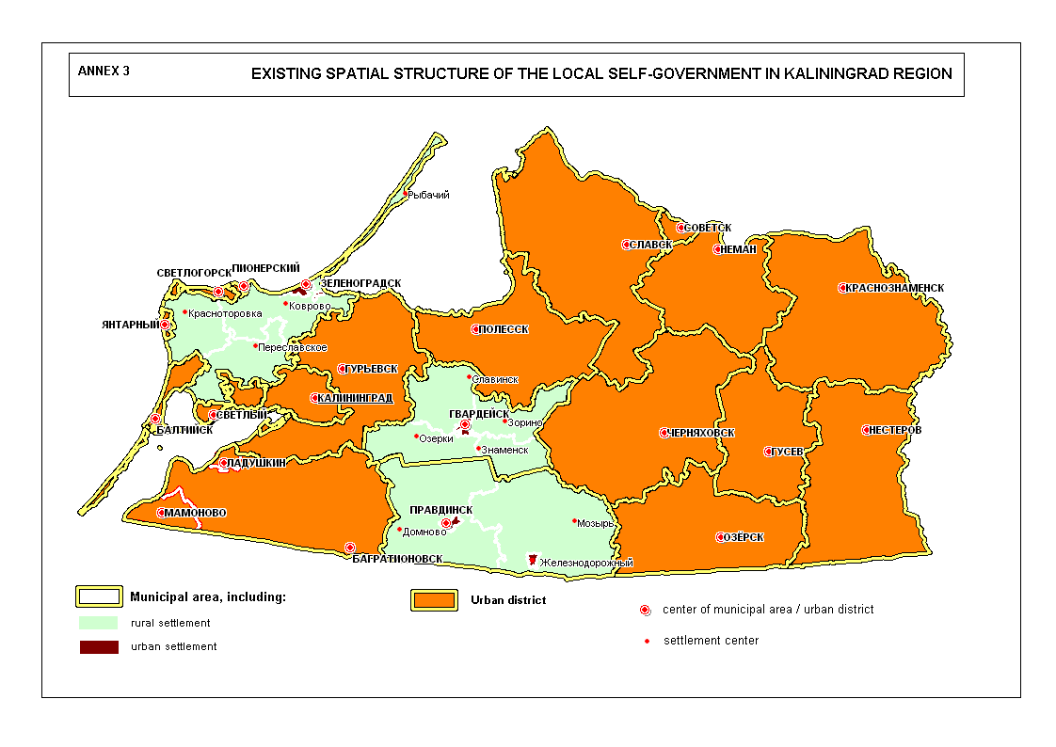
Picture. 4. Existing spatial structure of the local self-government in Kaliningrad region

Coordination process between the administrations of municipal areas and settlements within theirs’ confines is not well developed yet. In urban districts where fist-level municipalities are not provided, development of rural settlements is totally depends on decisions made on the level of the urban district.
The Kaliningrad region Government (represented by the Minister of territorial development and interaction with the LSG, M. Plijukhin) confesses that current scheme of the LSG is failed. Established urban districts, in fact, stay away of its meaning. Its worsening the management and forming inconvenience for the population. Moreover, the Statutory Court of Kaliningrad region invalidated the status of almost all urban districts. On the opinion of the Minister, optimization of the LSG structure is required.
The reform of the LSG proposed by the Kaliningrad region Government consists of two stages. At first stage 12 urban districts should be reorganized into municipal areas and five – into urban settlements.

2.5. Cross-border cooperation

Trans-boundary cooperation is carrying out on different levels – by regional authorities, state governments, NGOs. Cross-border regions, or so-called euroregions, are the most widespread form of trans-boundary cooperation in the Baltic Sea region.
Trans-boundary (cross-border) cooperation could be defined as more or less institutionalized process of interaction of local authorities of adjacent territories (regions) which are situated on the international boundary.
Euroregions are “training ground” where various practical measures for facilitation of cross-border regions development with the object of achievement of European socio-economic standards of living are tested. Their experimental nature caused by, first of all, additional opportunities for local self-government and entrepreneurship development due to new knowledge and experience in the sphere of cross-border cooperation as well as assistance on the part of partners.
Trans-boundary (cross-border) cooperation regions of the North-West Russia regard trans-boundary (cross-border) cooperation as a tool for renewal and formation of historically formed political, economic and cultural interactions with adjacent Scandinavian and Baltic states as well as for maintenance and development of competitive edge formed on both sides of the border. Cross-border contacts significantly liberalize capabilities of adjacent regions of Russia and the EU as well as allow to settle political, economic and social problems in more effective way particularly at the expense of the EU opportunities within the frames of Interreg program.
At present, Kaliningrad region is a member of five of eight euroregions with participation of regions of Russia: euroregions “Baltic”, “Neman”, “Sheshupe”, “Lyna-Lava”, “Saule”.

2.6. Resume

The analysis of urban-rural relations carried out in the framework of the Kaliningrad agglomeration allows to come to the following conclusions.
Inter-municipal cooperation.
The most developed sphere of municipalities cooperation (both urban and rural) is considered to be inter-municipal cooperation at various levels. And those rare examples of URP which exist in Russia are hidden behind the term “inter-municipal cooperation”. Those regional associations which arose during developing and reforming the system of self-governance dealt and deal first of all with political but not socio-economic problems.
АМО of the Kaliningrad region still consider that its main aim is to form and maintain conditions (political) for development of municipalities, their representation and their interests protection in bodies of legislative and executive power at federal and regional levels.
Under such conditions urban-rural partnership in the Kaliningrad region in its true sense is not in fact represented.
From numerous logistic links between cities and rural areas the most represented are the contacts, links or cooperation which develop in the following directions and formed objectively without influence (regulations) from the side of municipalities:
– pendulum labour migration of rural inhabitants to towns and (more rarely) vice verse;
– rest of town-dwellers in rural areas;
– suburbanization and connected with it housing construction in suburbs.
Labour migration.
Kaliningrad continues to be the centre for migrants’ attraction from the agglomeration zone. Developed transport communication allows rural inhabitants to commute to the regional centre every day. Thus the main direction is migration of rural population to Kaliningrad. The main reasons:
– different salary rate;
– lack of work places in rural areas;
– demand of metropolis for labour force.
Municipalities do not participate in regulation of the process of pendular labour migration and do not have sufficient instruments for it.
In 2002 IRSUR researchers carried out socio-economic assessment of the Sea Area, rural population employment and its swing mobility were studies. According to the results of the survey the main employers in rural areas continue to be such fields as education, trade and management. A lot of agricultural enterprises were closed. This fact makes male population find work in the regional centre.
Transport.
An important factor of the development of such kind of URP as labour migration is transport communication.
Notwithstanding the sufficient level of development of transport communication of settlements of agglomeration and regional centre there are also some problems. Transport on routes which connect district towns with rural settlements or night buses to Kaliningrad and back are often cancelled. It is connected first of all with insufficient conditions of bus park due to lack of circulating assets of a servicing enterprise. On the whole population is not satisfied enough with passenger transport communication.
Transport companies do not practically cooperate with local municipalities. It is necessary to regulate mechanisms of interests’ agreement of municipalities when forming a net of suburban routes.
Tourism.
Due to strong man’s impact onto the coast nowadays its environmental pollution is a serious problem. Places for spontaneous rest are not equipped, rubbish collection and removal lack. Initiatives of some public organizations or municipalities in this direction are only non-permanent and cannot solve the problem.
Local self-government having no financial means not once made drastic attempts to settle the problems (in this case – to stop access of passenger cars to the seaside), but without success. Office of Public Prosecutor appealed against this action foregrounding its decision by the fact that cost zone refers to federal land not municipal.
One more factor of URP is numerous lawn-and-garden plots (datschas) situated directly round Kaliningrad. In Kaliningrad alone at about 70 garden associations are registered.
Territory of Kaliningrad coastal zone requires considered perfection of planning organization and regulating functional use of its territories for its further sustainable development, formation and maintenance of favorable environmental conditions for population’s dwelling and rest.
For the last decades Se zone cities development is based on the principle of “linear town” extended along the Baltic Sea coast. If this tendency is preserved the entire Baltic Sea coast will be represented by one linear town. Such a conception is impossible due to following considerations. Firstly, the coastal zone will lose its diversity built on the combination of developed (urban) and open (natural) territories. Secondly, dispersal of capital resources along the coast will lead (and is leading) to irrational land use and immovable property in existing settlements. According to the said above the optimal model is a spatial model presupposing rational combination of compact urban zones with predominantly all-year-round resort-recreational service development and vast zones of nature conservation farming and recreation where objects of seasonal recreational service of both transforming and mobile forms can be situated.
In order to “unload” the main recreational centres of the coast it is necessary to involve also inner districts of the Sambian peninsula to develop new recreational complexes (Kulikovo, area near settlement Yantarny bereg, Shatrovo).
Along with construction of developed transport and engineering infrastructure systems, systems of sterilization of waste and utilization of sewer and refuse vast territories for preservation and reproduction of the most important natural resources should be reserved within the boundaries of the Sea recreational zone.
Agriculture products market.
The main objective of the agro-industrial complex of the SRZ is satisfaction of needs of local population, tourists and Kaliningrad citizens in meat and mild products, eggs, potatoes and vegetables. Launching enterprises producing ecologically pure products especially for resort areas and for export will be of great interest. Agrotourism development is expedient to provide benefits for farmers and private subsidiary farms at an appropriate level. This fact supposes development of farms which specialize on vegetables and potatoes growing as well as fruit and berries.
In collective and cash farms greater importance should acquire product producing in the framework of vertical cooperation (agriculture product produce – its processing – selling it through trading network and to catering enterprises). The main fields of specialization are meat and milk cattle-breeding, pig-breeding. Animal-breeding requires technical re-equipment.

Housing construction.
Housing construction is one of the most developed examples of town and rural areas cooperation. It is developed in a zone directly adjacent to Kaliningrad (Gurjevsky urban district) and on the coast (Zelenogradsky municipal area and Svetlogorsky urban district).
The main bulk of houses in the Kaliningrad region is built in the regional centre and its suburbs (Gurjevsky urban district) (table 7).
Table 7

Putting into operation apartment houses in agglomeration municipalities, 2007
 | Put into operation, total area in square metres |  | Including also in rural areas
 | total | Private houses from them | total | Private houses from them
Urban districts:
Kaliningrad | 469.050 | 112.722 | – | –
Pionersky | 21.750 | 1.257 | – | –
Baltijsky | 13.160 | 1.061 | – | –
Svetlogorsky | 33.283 | 11.580 | 1.335 | 1.335
Svetlovsky | 15.609 | 3.596 | 6.601 | 3.208
Bagrationovsky | 11.232 | 5.138 | 4.629 | 4.629
Gurjevsky | 78.217 | 64.169 | 59.569 | 51.592
Municipal areas:
Zelenogradsky | 40.333 | 16.263 | 17.249 | 9.044
Agglomeration without Kaliningrad | 213.584 | 103.064 | 89.383 | 69.808
Total: | 751.496 | 248.899 | 106.464 | 79.854

28,4% of all houses put into operation fall to the share of the agglomeration (share of Kaliningrad – 62,4%) in 2007. In other words only 9,2% fall to the share of the rest part of the region.
Round Kaliningrad first of all cottage and low-rise construction in the closest to the city settlements (Gurjevsk, Isakovo Maloe and Bolshoje, Orlovka, Vzmorje and others) is being developed. As a result along the whole perimeter round Kaliningrad relatively cheap cottage and townhouse construction – from new residential areas in settlement Shosejny to a great number of projects in four “eastern” directions: outside Borisovo, along the Moskovsky avenue, along Shaturskaya and Alexander Nevskogo streets - is being formed. That is why it is not surprising that ¼ of all individual construction in the region (25,8%) fall to the share of Gurjevsky urban district in 2007 and it is led mainly outside the town territory (64,6% or regional housing put into operation). In 2007 738 of residential houses were put into operation there whereas in Kaliningrad - only 14.
At the same time mass housing construction is represented in the district, first of all, along the main roads with a developed bus connection. Together it gave 10,4% of all the share in the region in 2007. For the last five years the housing of the Gurjevsk district has increased on 122% (picture 5).

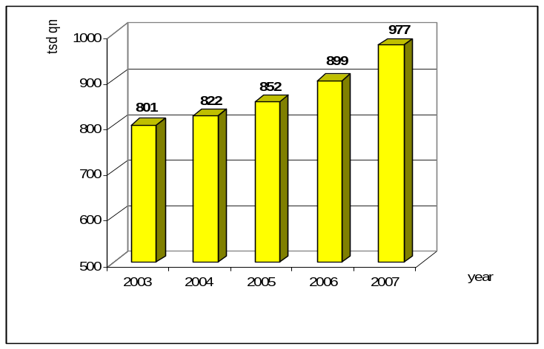
Picture. 5. Housing of Gurjevsky urban district (thousands of square metres by the end of the year)

Outside Kaliningrad suburbs construction is dynamically developing in a recreational zone. In 2007 to the share of Svetlogorsk fall 4,4%, to Zelenogradsky district – 5,4% of the regional index. In Svetlogorsk individual housing directly in a federal resort dominates (only 4% are in rural areas), whereas in Zelenogradsky district 42,8% of houses were put into operation in rural areas.
3. recommendations for urban-rural development in Kaliningrad region

Analysis of the existing statement of urban-rural partnership/relationships in Russia allows make the conclusion that notwithstanding on constant and dynamic relationships between cities and the countryside the phenomenon of urban-rural partnership (URP) is not occur in Kaliningrad region as well as in the rest regions of the NW Russia. Separate elements of cooperation do not contribute to the meaning of partnership because of main following reasons:
- lack of knowledge about content of URP to be an approach to solve development problems of different levels;
- unclear recognition of importance and costs/benefits consequences of URP implementation; lack of “best practice” experience;
- low initiative of local and regional authorities in a field of finding out of non-traditional view on spatial development, including internal and external cross-boundary aspects.
We are on the opinion that the following set of recommendations will promote development of new urban-rural relationships within the frames of inter-municipal cooperation on parity of urban and rural areas.

- Completion of the reform of local self-government
Formation of an effective system of the LSG is a basis of not only effective socio-economic development of Kaliningrad region but also of development of urban-rural partnership because it defines actors of this process.
The scheme of the LSG proposed by the Kaliningrad region Governments gains advantages in comparison with the current one (annex 3). However, its realization is not an easy matter and would take quite a long time. At present, the decision on reorganization of urban district into municipal areas is approved but not realized yet. The reason is that municipalities face major problems related to responsibilities of land use management within new municipal areas. Realization of the second stage of the reform is seems for us as quit illusive or at least a matter of long-term perspective. Negotiations with the population, deputies, NGOs, etc. will cause significant changes into proposed scheme of the LSG.
We propose “intermediate” option that could help to complete the first stage of the LSG reform developed by the Kaliningrad region Government (pic. 6).
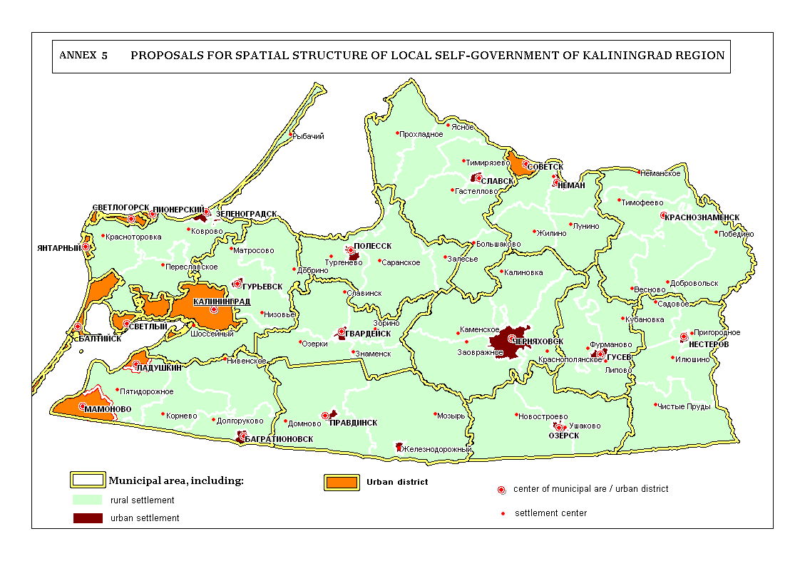
Picture 6. Proposals for spatial structure of local self-government of Kaliningrad region

2. Development of territorial planning and inter-municipal cooperation as a basis of URP
Territorial planning and inter-municipal cooperation should become a basis of urban-rural partnership development.
Within the framework of development of joint (consolidated) spatial planning scheme the borders of agglomeration (and, accordingly, and expedient list of the subjects required for realization of joint development strategy) from one side and range of participation and financing of joint activities on the part of separate municipalities, interested persons and organizations from the other side could be defined. Such approach gives an opportunity to overcome departmental borders during planning and management of agglomerations. Some statements of strategic URP development could be defined within the frames of the spatial development scheme of Kaliningrad region (the document of a regional significance).
Inter-municipal cooperation is a new phenomenon in Russia. In the course of the current LSG reform this kind of relationships, first of all in a legislative sphere, move to the forefront. In general, inter-municipal development is historically conditioned and actual process which comes to being due to awareness by the municipalities the objective necessity to incorporate in order to decide common problem. At the same time, it is necessary to broaden scope of actions of municipal associations.
The following variants of economic problems solution can be offered:
- service purchase of a “big” municipality by several “small” ones (typical services being under such agreements are shelters and crisis centres);
- setting up organizations the governing bodies of which include representatives of several municipalities (typical examples are transport companies);
- partnership between several municipalities in realizing big projects (the example is construction of the plant for waste processing) and others.

3. Transition form decision of political issues to the social-economical issues in the inter-municipal cooperation.
The distinction of Russia from other countries is political context of various kinds of municipal associations. The Federal law “On main principles of local self government organization in the Russian Federation” clearly provides creation of only one kind of municipal associations – the one to provide for remedy. That’s why this kind of municipal association is the most widespread. Functioning of “economic” or “management” associations is not well developed in Russia yet.
The transition means the strengthening of joint partner work in municipal cooperation issues on “urban-rural” level. It concerns both municipalities and regional associations. New urban-rural partnerships already appear in Russia but more often it is identified as inter-municipal cooperation (the concept of ‘rural-urban partnership’ itself did not come into lexicon of municipal Heads). As an example we can take Chelyabinsk and Tver region. It should be noted that in Tver region in February the Agreement on mutually beneficial inter-municipal cooperation between Tver city and adjacent Kalinin and Rameshkov districts has been signed. Such Agreements come into practice in many regions in Russia step by step.
Thereupon the actual problem in the development of urban-rural partnership is the increasing of skills level of public employees. Within the municipal reform there is a need for qualified experts. It is reputed that the number of functions realized by the local authorities should be equal to the number of experts. The problem is not easy, but it can be solved. The ways to solve the problem could be the reasonable territory enlargement or establishment of inter-municipal formation. First of all such enlargement gives the opportunity to solve local issues more competently and effectively at once; secondly, it gives the possibility to have more recourses to solve local issues.
At the same time the Association of municipalities of Kaliningrad region should have stronger influence on decision of complex social-economic issues of territorial development.
Thus, as we believe, the establishment of coordination centre for cooperation strategy defining should be as the start point for Urban-Rural Partnership. The Board on socio-economic development of the territories or the Agglomeration Board could be such the organization where the heads of municipalities of Kaliningrad and its inner territories should be involved in. The functions of the Board should be following:
– Identification of potentially conflict issues among municipalities and searching for compromise options satisfying all stakeholders;
– Identification of the most favourable spheres of inter-municipal cooperation in the framework of the agglomeration;
– Agreement on implementation of joint inter-municipal projects, making coordinated decisions on their organization and financing;
– Formation of the general vision of agglomeration development strategic prospects by the leaders of participating municipalities;
– Support of inter-municipal cooperation in issues concerning creation of favourable image of agglomeration in the eyes of investors and increasing its competitiveness;
– Support of inter-municipal cooperation concerning participation of municipalities-members of the agglomeration, in federal and regional target programs.
At present, all municipalities of Kaliningrad region work on carrying out of their programs of socio-economic development. Overview of existing programs shows that being important instrument of partnership, they do not touch aspects of urban-rural cooperation. In this way, we propose to include a section on development of socio-economic partnership. The partnership in the socio-economic sphere (both rural municipalities with each other, and cities with surrounding countryside) can be developed in such spheres as:
– transport (development of transport infrastructure and inter-settlement transport service) - cooperation should focus on regulation of mechanisms of coordination of municipal interests in establishment of suburban routes network in order to optimize it; the agreement should be based on the analysis of highways congestion along the route, presence of the equipped final stops on the territory of different municipalities, organization of the monitoring system of passenger service quality and following the schedule, etc.
– health care – inter-municipal agreements can provide the inhabitants of suburban zone with services of narrow specialized doctors working in these territories and also provide citizens with sanatorium-preventive services (such cooperation does not contradict existing financing system of medical services);
– education - General issues in the field of education are caused, in particular, by concentration of specialized secondary educational institutions and higher education institutions, basically, in Kaliningrad;
– consumer market, agricultural market development - the objective situation connected, on the one hand, with the greatest concentration of retailers, who have the opportunity to sell better goods on lower price and, on the other hand, the opportunity for rural producers to sell their own production on higher price in the city, determines the presence of sustainable connection of population of surrounding territories with city trade infrastructure; active cooperation of urban and rural territories concerning promotion of agriculture production to the city market is necessary;
– communal services (teamwork of emergency services, "first aid" services, gasification, export and recycling of garbage on territories of rural municipalities);
– tourism (keeping of resting zones in good condition);
– development of cities – especially in peripheral area where functional urban-rural interdependence is more strong; creation of new “points of growth”.

4. Introduction of URP ideology to Regional strategy of agro-industrial sector development.
Analysis of main strategic documents on development of urban and rural areas shows that URP approach responses to their goals and target and could be softly introduced in order to enrich methodology of regional development planning as well as decision-making. At regional level URP development mostly deals with aspects of agro-industrial sector strategic development. Other aspects of urban-rural relationships are engaged with the sphere of inter-municipal cooperation.
The practice demonstrates that organization of agro-holding companies and integration of manufacturing enterprises of cities and agricultural organizations are the mechanism of rise of agro-industrial potential.
Agro-business development faces the problem of lack of professionals (managers). Managers with Soviet-time experience do not meet the market requirements and could be involved only as consultants. Young and perspective mangers prefer oil and bank business where provide higher salaries. At present, companies should practices the training of professional by themselves.

5. Diversification of rural areas functions in the context of urban-rural partnership development
This process in the suburban zone is already going, but until recently it was spontaneous. Very often investors allocate manufactures near the regional center without support of local authorities, using this location as a resource of labor force, transport infrastructure, cheapness of the ground areas, etc.
Thus, diversification of rural areas functions is firstly connected with industry development, considering that the industry is one of the major branches of economy. For further social and economic development of municipalities of the agglomeration (and not only) it is necessary to create conditions for establishment of hi-tech and competitive enterprises. One of the possible decisions could be "investment passports of municipalities" as factor of investors` attraction. This process is already started (Mamonovsky municipal district).
The optimal form of such enterprises development is establishment local industrial zones. It is necessary to prepare investment platforms for localization of perspective (taking into account the specific features of municipality and tendencies of regional economy development) types of industrial activity. It finds reflection in such new phenomenon for the regional rural areas as "investment passports". The efforts of the administration should be aimed at preparation of investment platforms for location of perspective enterprises (taking into account development of municipality and tendencies of regional economy development). It is considered it can be:
- manufacture and assembly of complex home appliances;
- textile manufacture;
- innovative manufactures;
- woodworking and manufacture of furniture;
- building industry;
- food manufacture.
Thus, according to the territorial zoning of the Gurjevsk municipal district 10 platforms of apprx. 600 hectares are already allocated for industrial zones.
In long term placing here shopping centers could be one more way of diversification of rural areas functions.

6. Urban-rural networking development in the field of sub-urbanization regulation.
According to the current Master plan the development of Kaliningrad is planned for the prospect of 2015 within existing city line. However, the new city-manager Mr. Felix Lapin sees its potential for development: «It is obvious that urban environment requires development […]. Development should be integrated due to reconstruction and renewal of obsolete buildings, construction of new dwelling areas and cooperation with neighbouring municipalities».
This kind of Urban-Rural Partnership in the field of town-planning regulation and land use implies coordination of the work on elaboration or updating of territorial planning schemes by the neighbouring municipalities taking into account the objective tendencies and approaches to organization of both intra-city space, and space of surrounding territories.
It is necessary to consider that modern tendencies of development of cities lead to concentration of hi-tech and innovative kinds of activity, and also cultural and administrative functions in cities. During the transformation of intra-city space the city "shares" those kinds of activity, which are not peculiar to modern big cities, with surrounding territories: for example, activities which demands big areas, cheaper resources, more favourable ecological situation than city can provide. However, it does not mean that the city is interested in occupying ecologically clean territories (which are necessary for recreation) with the industrial areas. Within the agglomeration each territory finds specialization which is most favourable for it and allows using resources according to the interests of the population, and at the same time to use potential of the neighbouring territories on mutually advantageous bases.
It seems that the creation of working group for harmonization of spatial policy could be as the solution of this problem, and this group should involve competent specialists and deputy heads of economical issues departments of municipalities.
Thus, complex territorial planning of municipal development is one of the basic conditions for effective and sustainable economy development and increasing of investment attractiveness of any municipality as well. However, its context (until today) within the Strategy of socio-economic development of municipalities, basically, is limited by functional zoning with the aim of optimal allocation of industrial zones taking into account the development of transport and engineering infrastructure, sustainable development of system of settlement, nature protection as the result of recreation development, maintenance of quality and productiveness of farmlands, protection of the objects of historical heritage. There are two basic parts: housing construction and allocation of objects of municipal infrastructure of the city in a suburb.
It could be defined two main components of this process: house building and siting of municipal infrastructure objects in a suburb.

7. Delegation of greater powers on management of development of recreation areas from the federal, regional level to the municipal one
The overall objective of this direction of Urban-Rural Partnership is the creation of favorable conditions for recreation namely the organization of places of short-term and long-term recreation in the suburb. Now tourism in the coastal recreation zone has mainly spontaneous character if we speak about local city one-day tourism. This zone mainly used by citizens of Kaliningrad who comes to the coast by own automobile transport. Some people use public transport (buses, railway).
The main problem here is ecological pollution. The local government repeatedly undertake attempts to regulate this problem (regulation in this case is closing of the access to the coast for automobile transport), but unsuccessfully. The Office of Public Prosecutor protested these actions since the coastal area are the federal lands. Municipalities should be delegated more power on management of recreation zone on their territories. Otherwise the problem of pollution and transportation of disposal will be unsolved. Some public organizations are trying to find a way out, but unsuccessfully.
Thus, there is a need in joint programs on development of recreation zone between the city and the countryside.

8. Development of the URP cross-boundary cooperation with neighboring countries
Euroreigons are the most widespread form of cross-boundary cooperation. Euroregions are the training ground for approval of various practical frameworks on extension of border territories. Experimental character of euroregions caused by additional opportunities for development of local self-government and entrepreneurship by virtue of new knowledge, experience and support from the side of partners. It is more or less institutional process of interaction of neighboring municipalities on the both sides of the border.
The most advanced fields of URP cross-border cooperation could be as following:
- development of transport-logistic complex;
- development of tourism and recreation infrastructure (especially agrotourism);
- agro-industrial cooperation on the basis i.e. of different harvest time of barriers and crop in neighbouring regions;
- international marketing.

9. Development of inter-municipal cultural exchange.
If we talk about the cultural exchange we talk not only about the strengthening of the cultural role of metropolitan area in relation to suburban areas but about equal partnership as well. There are interesting things in the city and the countryside as well. There is a great number of cultural objects in the countryside located around the Kaliningrad city.
This issue includes organization of centers of inter-municipal cultural service in a form of a cultural oasis. During resent 15-18 years many cultural (community) centers were closed because of lack of financing. In this conditions, the necessity of inter-municipal cultural centers development become a priority. Some municipalities could be such centers of inter-municipal cultural exchange.

10. Enhancement of public service accessibility for the population.
According to amount of the population in urban and rural settlements and their position in the region system of settlements, it is necessary to enhance development of certain centers of public service. Also it is recommended to take into account social norms and standards approved in the RF (the decree of the RF Government “On social norms and standards” 3.07.1996, № 1063-р) (pic. 7).
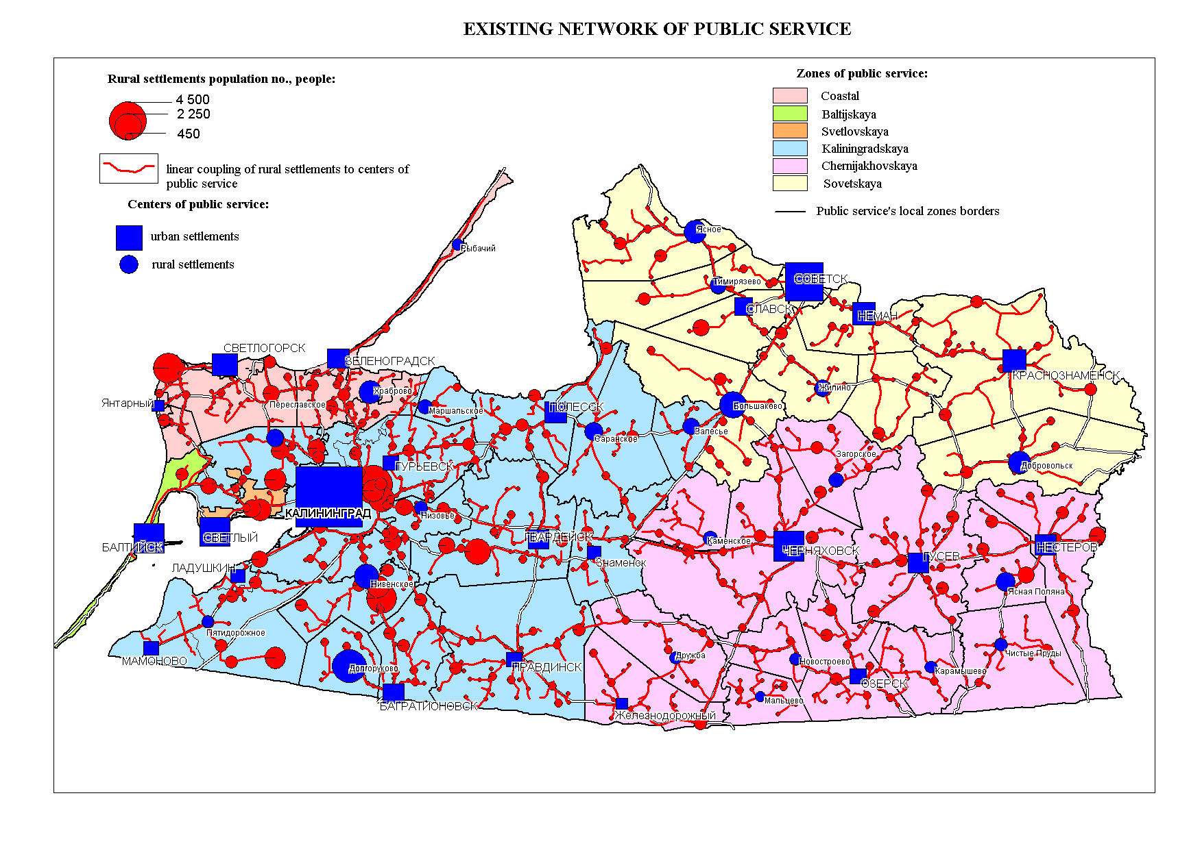
Picture 7. Existing network of public service

In order to provide the population of Kaliningrad region it is recommended to organize four-level system of public service infrastructure (pic. 8).
Public service complex of 1st level (PSC-1) consists of objects of neighbourhood service with working radius up to 500 m for urban areas and 2-6 km for rural areas: feldsher-midwife stations, pharmacy, pre-school institutions, library branches, elementary and secondary schools (for settlements with more than 1000 dwellers), clubhouses, supermarket, catering facilities. It is recommended to organize PSC-1 in 60 settlements of Kaliningrad region.
Public service complex of 2nd level (PSC-2) consists of objects of daily public service with working radius up to 1000 m for urban areas and up to 20 km for rural areas (20-min. public transport accessibility): secondary schools, out-of-school institutions, centers of culture and recreation, libraries, sport and health facilities, post office, bank branches. It is recommended to organize PSC-2 in 36 settlements of Kaliningrad region.
Public service complex of 3rd level (PSC-3) consists of objects of PSC-1, PSC-2 but also objects of periodic service: hospitals, first-aid stations, welfare offices, cinema, dancing saloon, specialized stores, public service establishment, bank branches. It is recommended to organize PSC-3 in 12 settlements of Kaliningrad region.
Public service complex of 4th level (PSC-4) consists of objects of PSC-1, PSC-2, PSC-3 but also objects of episodic service: exhibition halls, concert halls, theaters, specialized hospitals, dispensary. It is recommended to organize PSC-4 in Kaliningrad and Chernjakhovsk. Separate objects of episodic service could be also organized in other urban and rural settlements due to these unique historic and environmental conditions or local initiatives.
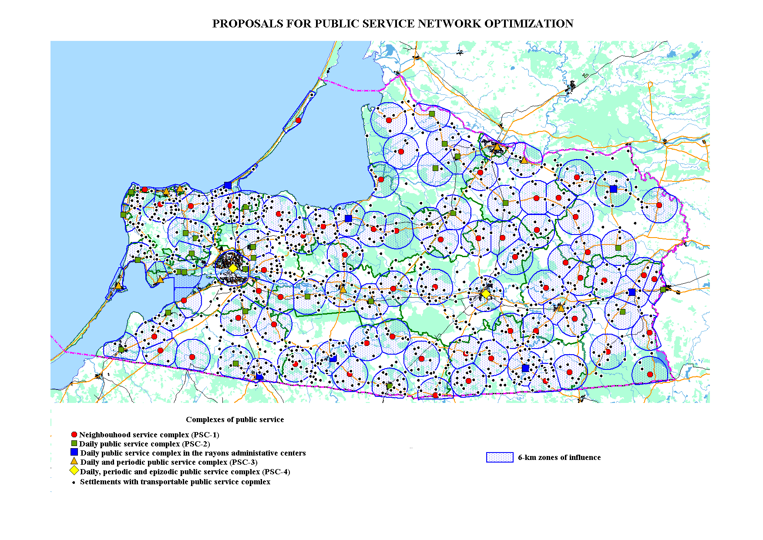
Picture 8. Proposals for public service network optimization

In article 3 of the document it is stated that the aim of Spatial Development Perspective is to add to balanced and sustainable development of the territory of the European Union. It is important to achieve three main fundamental targets of the European policy in all EU regions. These targets comprise economic and social understanding; preservation and management of natural resources and cultural heritage; balanced competitiveness of the European territory”. The program is adopted on 11.05.1999.
For example, N.V. Tarasova Urban-rural migrations in Russia: modern tendencies and socio-demographic consequences // SotsIs: Socio researches – Мoscow, 1995.– №12.– pp. 48-58.
Such an exotic notion as «urban-rural women» also occurs, but it concerns Tadzhikistan www.swisscoop.kg/ressources/resource_rus_25039.pdf
V.V. Vagin. Sociology of the city, 2000
http://www.referama.ru/txt.php?str=3&srch=&ch=15606
http://spc.nsc.ru/annot.htm
Federal act «About the Main Principles of Local Governance Organization in the Russian Federation» on 6.10.2003 № 131−FZ
Zones of influence of main centers of regional system of settlement were defined in order to off-load the regional center and enhance the service of rural areas (accessibility of public service infrastructure, production delivery, transport service) / E.E.Korkisch, H.Heinz Das nordliche Ostpreussen. Eine Studie zur Landesstruktur, 1996, Freising.
13,4% of all acreage planted in Kaliningrad region belongs to farmers
After Slavsky urban district– 168,4 c/h
Average result for the Kaliningrad region is 157,6 c/h
Taking into account the real streams of “guest workers” the migration streams for the last several years can be estimated as stable on the level of 15 thousand of people per year.
Transport enterprises of Kaliningrad (big and middle) transported 2313 of people in 2006 in suburban direction
36 technical units are served for 5 bus routes. For 2006 3,1 million of people were transported and 66,8 thousands of trips were made.
The quotation of M.I. Liborakin. Problems and perspectives of local government: independent examination of the reform. The fund “Liberal mission”, the fund “Institution of the economics of the town”.
V. Melnichenko «It is shameful to sit with a mouth open and wait till something is put into it». Russian Federation today, №23, December 2003, p.38
“Kaliningradskaya pravda”, July18 2007.
«the proposed scheme is not a dogma, — as the Governor of the Kaliningrad region, G. Boos mentioned — we have to prove to the people that new LSG territorial structure will enhance theirs life and provide economic growth of each municipality and region as a whole» // “Kaliningradskaya pravda”, July18 2007.
Annually more than 200 individual houses are put into operation in the district.
Insignificant indexes can be explained by territory specifications of the Svetlogorsky urban district.
Report of the mayor of Chelyabinsk Mr. Yurevich at the theoretical and practical conference “Urban agglomerations” (Chelyabinsk, 30th of January 2008)
The aim of Agreement is the improvement of the socio-economic situation and increasing of inhabitant’s standard of life on the basis of joint programs realization and mobilization of investments. Districts adjacent to the regional center look to for the help of Tver city with its developed infrastructure and industrial potential. The background for such situation is usual for all territory of Russia where adjacent districts are very close to regional center. There is a labour migration from districts to city and at the same time the citizens owns cottages or private houses. Recreation activities for pupils from Tver every year is organized in summer camps which are located on the territory of Kalinin district. Within this Agreement many issues will be solved such as: transport connection, gasification, reparation of motorways, settlements improvement, forest conservation, upkeep of recreation zones.
For instance «Invest-project Ltd» – assembly of home appliances in the settlement of Pereslavskoye.
The settlement of Konstantinovka – 80 ha; the area of the settlement of Poddubnoye–Yablonevka–Polevoye – 250 hectares; the area of the settlement of Dorozhnoye – 30 hectares; the settlement of Laskino – 20 hectares; the settlement of Svetloye – 40 hectares; the settlement of Khrabrovo – 30 hectares; the settlement of Vasilkovo – 60 hectares; the settlement of Maloye Lesnoye–Lesnoye – 30 hectares; the settlement of Lugovoye–Kozlovka – 50 hectares; the settlement of Petrovo – 15 hectares.

