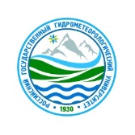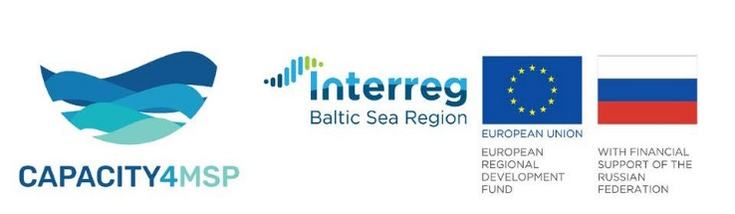

|  |  |
| --- | --- |
| **REGISTRATION FORM**  International scientific and practical conference  "ECO-FRIENDLY DEVELOPMENT OF COASTAL AND MARINE AREAS"  **December 9-10, 2021**, St. Petersburg (Russia)  Parliamentary Center IPA CIS  (in hybrid format) | |
| FULL name |  |
| Е-mail |  |
| Organization name |  |
| Position |  |
| Form of participation (underline/**highlight**) | Face-to-face  Online |
| Form of participation: observer /presenter | Observer  Presenter |
| Session name (*leave the relevant one*) | 1. General meeting of the conference  (December 9-10, 2021) "ECO-FRIENDLY DEVELOPMENT OF COASTAL AND MARINE AREAS"  2. Round table "Russian initiatives for the effective implementation of the Black Sea Blue Growth Strategy" (December 10, 2021) |
| Abstract title  (*please, attach the Abstract text of* ***max 1 page*** *to this form in case of participation with a presentation*) |  |

Please send the completed registration form to the address: [ershova@rshu.ru](mailto:ershova@rshu.ru)

**ALL fields are MANDATORY.**

Deadline for submission of abstracts and registration for participation: **November 20, 2021.**

Secretariat:

Ershova Alexandra, Ph.D., ershova@rshu.ru

Mob. + 7-921-3484823